**Index.html**

<!DOCTYPE html>

<html lang="en">

<head>

<meta charset="utf-8">

<meta name="viewport" content="width=device-width, initial-scale=1">

<link rel="stylesheet" href="https://maxcdn.bootstrapcdn.com/bootstrap/3.4.1/css/bootstrap.min.css">

<script src="https://ajax.googleapis.com/ajax/libs/jquery/3.5.1/jquery.min.js"></script>

<script src="https://maxcdn.bootstrapcdn.com/bootstrap/3.4.1/js/bootstrap.min.js"></script>

<link rel="stylesheet"type="text/css"href="jumbotron.css"/>

<link rel="stylesheet"type="text/css"href="body.css"/>

<link rel="stylesheet"type="text/css"href="h41.css"/>

<title>Adventour in Malaysia</title>

<style>

a:link {

color: #996515;

}

a:visited {

color: green;

}

a:hover {

color: red;

}

a:active {

color: yellow;

}

.navbar-custom{

background-color:#13CDDF;

}

</style>

</head>

<body>

<div class="jumbotron text-center">Adventour in Malaysia</div>

<nav class="navbar navbar navbar-custom">

<div class="container-fluid">

<div class="navbar-header">

<button type="button" class="navbar-toggle" data-toggle="collapse" data-target="#myNavbar">

<span class="icon-bar"></span>

<span class="icon-bar"></span>

<span class="icon-bar"></span>

</button>

</div>

<div class="collapse navbar-collapse" id="myNavbar">

<ul class="nav navbar-nav">

<li><a href="index.html">HOME</a></li>

<li><a href="places.html">PLACES</a></li>

<li><a href="hotels.html">HOTELS</a></li>

<li><a href="activities.html">ACTIVITIES</a></li>

<li><a href="info.html">MORE INFO</a></li>

</ul>

<ul class="nav navbar-nav navbar-right">

<li><a href="login.html"><span class="glyphicon glyphicon-user"></span>Sign Up/Sign In</a></li>

<li><a href="enquiry.html"><span class="glyphicon glyphicon-list-alt"></span>Enquiry</a></li>

<li><a href="feedback.html"><span class="glyphicon glyphicon-thumbs-up"></span>Feedback</a></li>

</ul>

</div>

</div>

</nav>

<div class="row">

<div class="col-sm-12">

<img class="img-responsive" src="tour.jpg" width=100% height=100%/>

</div>

<div class="col-sm-12">

<hr>

<h4><center><b>&copy;Developed by M.V.Priyadharsini-18ITR077</b></center></h4>

<hr>

</div>

</div>

</body>

</html>

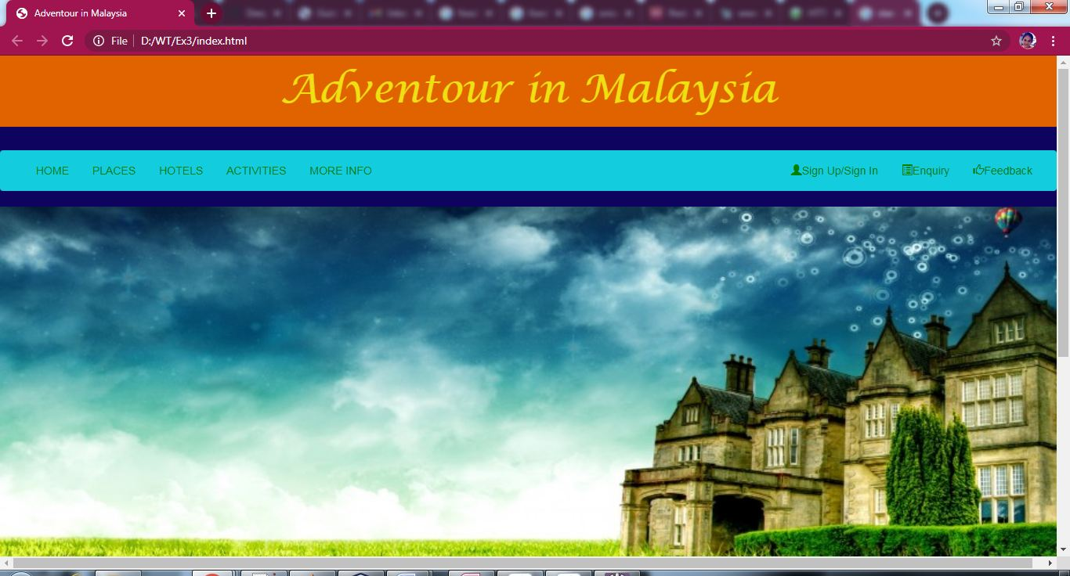

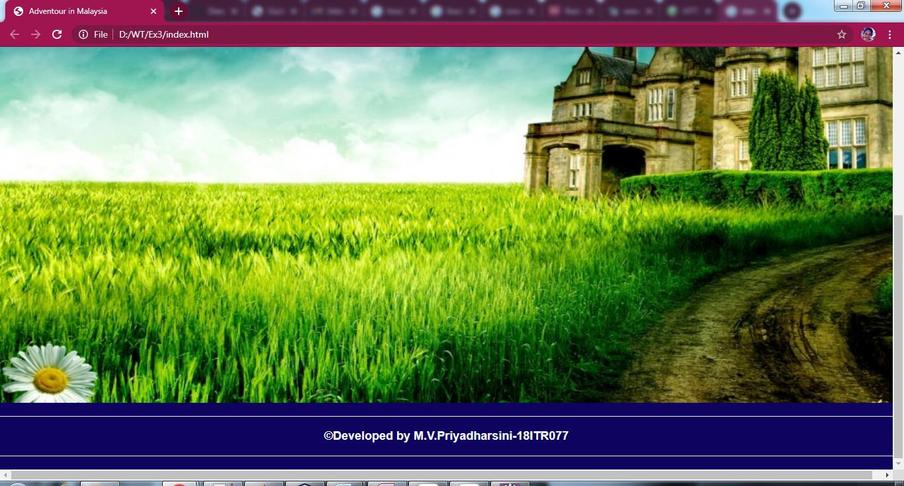

**Login.html**

<!DOCTYPE html>

<html lang="en">

<head>

<meta charset="utf-8">

<meta name="viewport" content="width=device-width, initial-scale=1">

<link rel="stylesheet" href="https://maxcdn.bootstrapcdn.com/bootstrap/3.4.1/css/bootstrap.min.css">

<script src="https://ajax.googleapis.com/ajax/libs/jquery/3.5.1/jquery.min.js"></script>

<script src="https://maxcdn.bootstrapcdn.com/bootstrap/3.4.1/js/bootstrap.min.js"></script>

<link rel="stylesheet"type="text/css"href="h41.css"/>

<link rel="stylesheet"type="text/css"href="a1.css"/>

<link rel="stylesheet"type="text/css"href="h1.css"/>

<link rel="stylesheet"type="text/css"href="center.css"/>

<link rel="stylesheet"type="text/css"href="jumbotron.css"/>

<link rel="stylesheet"type="text/css"href="body.css"/>

<style>

a:link {

color: #996515;

}

a:visited {

color: green;

}

a:hover {

color: red;

}

a:active {

color: yellow;

}

.navbar-custom{

background-color:#13CDDF;

}

.navbar-nav > li{

padding-left:30px;

padding-right:120px;

}

</style>

<title>Login</title>

</head>

<body>

<div class="jumbotron text-center">Adventour in Malaysia</div><br>

<nav class="navbar navbar navbar-custom">

<div class="container-fluid">

<div class="navbar-header">

<button type="button" class="navbar-toggle" data-toggle="collapse" data-target="#myNavbar">

<span class="icon-bar"></span>

<span class="icon-bar"></span>

<span class="icon-bar"></span>

</button>

</div>

<div class="collapse navbar-collapse" id="myNavbar">

<ul class="nav navbar-nav">

<li><a href="index.html"><b>HOME</b></a></li>

<li><a href="places.html"><b>PLACES</b></a></li>

<li><a href="hotels.html"><b>HOTELS</b></a></li>

<li><a href="activities.html"><b>ACTIVITIES</b></a></li>

<li><a href="info.html"><b>MORE INFO</b></a></li>

</ul>

</div>

</div>

</nav>

<p><a href="index.html" style="color:pink">Back</a></p>

<form action="index.html" method="post">

<div class="container">

<div class="row">

<div class="col-md-12">

<h1><center>User Login</center></h1>

<h3>

<center>

Username:

<input type="text" id="uname" name="uname" required><br><br>

Password:

<input type="password" id="pwd" name="pwd" required style="color:black"><br><br>

<center><input type="submit" value="Log In" style="color:black"/>&ensp;&ensp;<input type="reset" value="Reset" style="color:black"/></center><br>

Don't have an account?Click here to <a href="signup.html" style="color:pink">register</a>

</center>

</h3>

</div>

</div>

</div>

</form>

<br><hr>

<div class="col-md-12">

<h4><center><b>&copy;Developed by M.V.Priyadharsini-18ITR077</b></center></h4><hr>

</div>

</html>

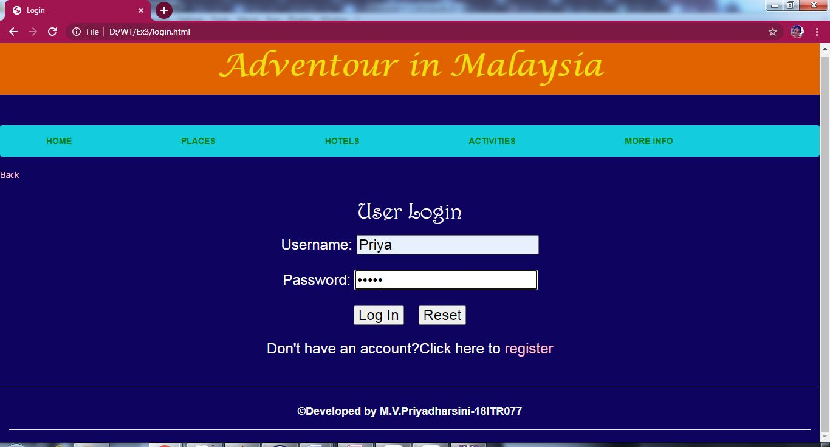

**Signup.html**

<!DOCTYPE html>

<html lang="en">

<head>

<meta charset="utf-8">

<meta name="viewport" content="width=device-width, initial-scale=1">

<link rel="stylesheet" href="https://maxcdn.bootstrapcdn.com/bootstrap/3.4.1/css/bootstrap.min.css">

<script src="https://ajax.googleapis.com/ajax/libs/jquery/3.5.1/jquery.min.js"></script>

<script src="https://maxcdn.bootstrapcdn.com/bootstrap/3.4.1/js/bootstrap.min.js"></script>

<link rel="stylesheet"type="text/css"href="h41.css"/>

<link rel="stylesheet"type="text/css"href="h1.css"/>

<link rel="stylesheet"type="text/css"href="h3.css"/>

<link rel="stylesheet"type="text/css"href="h2.css"/>

<link rel="stylesheet"type="text/css"href="span.css"/>

<link rel="stylesheet"type="text/css"href="a1.css"/>

<link rel="stylesheet"type="text/css"href="jumbotron.css"/>

<link rel="stylesheet"type="text/css"href="body.css"/>

<title>Signup</title>

<style>

.head{

background-color:orange;

}

a:link {

color: #996515;

}

a:visited {

color: green;

}

a:hover {

color: red;

}

a:active {

color: yellow;

}

.navbar-custom{

background-color:#13CDDF;

}

.navbar-nav > li{

padding-left:30px;

padding-right:120px;

}

</style>

</head>

<body>

<div class="jumbotron text-center">Adventour in Malaysia</div><br>

<nav class="navbar navbar navbar-custom">

<div class="container-fluid">

<div class="navbar-header">

<button type="button" class="navbar-toggle" data-toggle="collapse" data-target="#myNavbar">

<span class="icon-bar"></span>

<span class="icon-bar"></span>

<span class="icon-bar"></span>

</button>

</div>

<div class="collapse navbar-collapse" id="myNavbar">

<ul class="nav navbar-nav">

<li><a href="index.html"><b>HOME</b></a></li>

<li><a href="places.html"><b>PLACES</b></a></li>

<li><a href="hotels.html"><b>HOTELS</b></a></li>

<li><a href="activities.html"><b>ACTIVITIES</b></a></li>

<li><a href="info.html"><b>MORE INFO</b></a></li>

</ul>

</div>

</div>

</nav>

<p><a href="login.html" style="color:pink">Back</a></p>

<h1><center>Please enter the following details to signup</center></h1><br>

<form method="post" action="res.html">

<fieldset>

<h3>

<div class="head">

<h2><center>Personal Information</center></h2>

</div>

<div class="container">

<div class="row">

<div class="col-md-12">

First Name:

<span style="width:100px"></span>

<select id = "salutation" style="color:black">

<option value = "Mr.">Mr.</option>

<option value = "Ms.">Ms.</option>

<option value = "Mrs.">Mrs.</option>

<option value = "Dr.">Dr.</option>

</select>

<input type="text" id="fname" name="fname" required style="color:black"><br><br>

Last Name:<span style="width:105px"></span>

<input type="text" id="lname" name="lname" required style="color:black"><br><br>

Date of Birth:<span style="width:90px"></span>

<input type="date" id="dob" name="dob" required style="color:black"><br><br>

E-mail:<span style="width:140px"></span>

<input type="email" id="email" name="email" placeholder="abc@gmail.com" required style="color:black"><br><br>

Phone Number:<span style="width:60px"></span>

<input type="tel" id="tel" name="tel" pattern="[0-9]{10}" placeholder="Should contain 10 digits" required style="color:black"><br><br>

Country:<span style="width:130px"></span>

<input list="countries" name="country" id="country" required style="color:black">

<datalist id="countries">

<option value="Albania">

<option value="Britain">

<option value="India">

<option value="Japan">

<option value="South Korea">

<option value="United States of America">

</datalist><br><br>

City:<span style="width:160px"></span>

<input type="text" id="cname" name="cname" required style="color:black"><br><br>

Address:<span style="width:130px"></span>

<textarea rows="4" cols="50" required style="color:black"></textarea><br><br>

Do you have or had any of the following?<br><br>

<input type="checkbox" name="disease" id="heart disease" style="color:black">

Heart disease<br>

<input type="checkbox" name="disease" id="eye disease" style="color:black">

Eye disease<br>

<input type="checkbox" name="disease" id="dermatologic" style="color:black">

Dermatologic<br>

<input type="checkbox" name="disease" id="gastrointestinal" style="color:black">

GastroIntestinal<br>

<input type="checkbox" name="disease" id="gyenecological" style="color:black">

Gyenecological<br><br>

Allergies if any:<span style="width:70px"></span>

<input list="allergy" name="allergies" id="allergies" style="color:black">

<datalist id="allergy">

<option value="Skin">

<option value="Drug">

<option value="Food">

<option value="Insect">

<option value="Pet">

<option value="Pollen">

</datalist>

<div class="head">

<h2><center>Login Information</center></h2>

</div>

Username:<span style="width:120px"></span>

<input type="text" id="uname" name="uname" required style="color:black"><br><br>

Password:<span style="width:125px"></span>

<input type="password" id="pwd" name="pwd" required style="color:black"><br><br>

<center><input type="submit" value="Submit" style="color:black"/>&ensp;&ensp;<input type="reset" value="Reset" style="color:black"/></center>

</h3>

</fieldset>

</form>

</div>

</div>

</div>

<br>

<div class="col-sm-12">

<h4><hr><center><b>&copy;Developed by M.V.Priyadharsini-18ITR077</b></center></h4><hr>

</div>

</body>

</html>

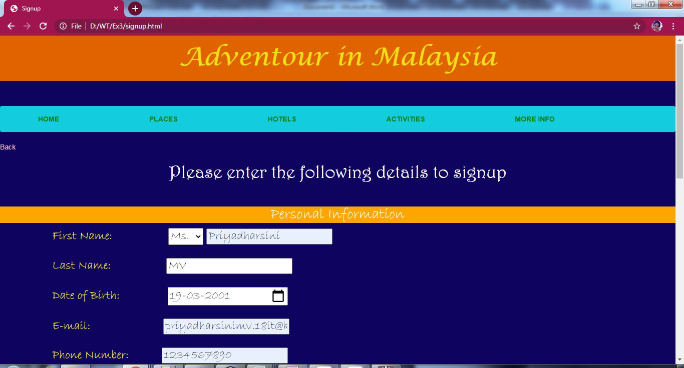

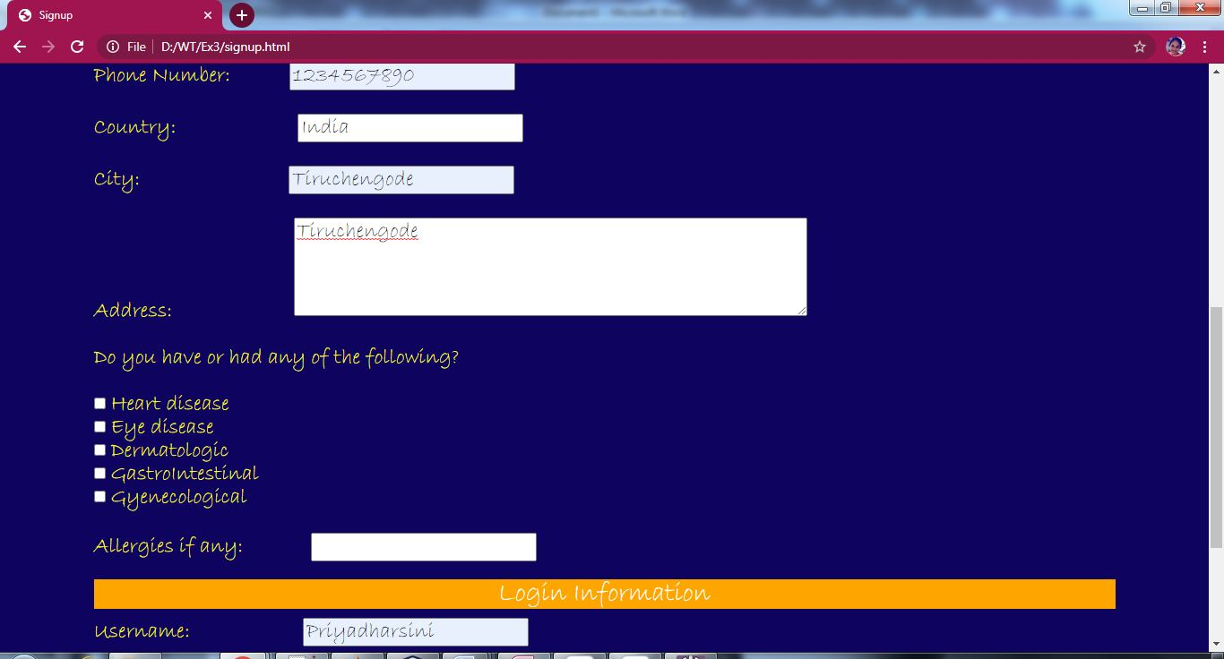

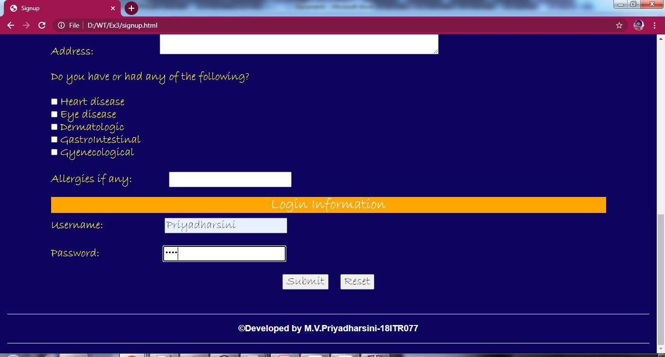

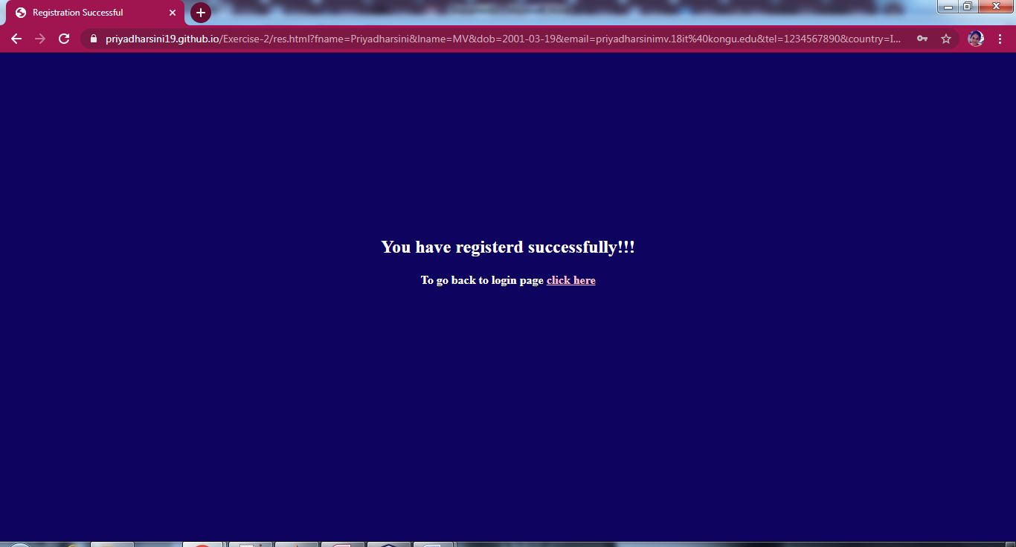

**Enquiry.html**

<!DOCTYPE html>

<html lang="en">

<head>

<meta charset="utf-8">

<meta name="viewport" content="width=device-width, initial-scale=1">

<link rel="stylesheet" href="https://maxcdn.bootstrapcdn.com/bootstrap/3.4.1/css/bootstrap.min.css">

<script src="https://ajax.googleapis.com/ajax/libs/jquery/3.5.1/jquery.min.js"></script>

<script src="https://maxcdn.bootstrapcdn.com/bootstrap/3.4.1/js/bootstrap.min.js"></script>

<html>

<head>

<link rel="stylesheet"type="text/css"href="h41.css"/>

<link rel="stylesheet"type="text/css"href="h1.css"/>

<link rel="stylesheet"type="text/css"href="h3.css"/>

<link rel="stylesheet"type="text/css"href="h2.css"/>

<link rel="stylesheet"type="text/css"href="a1.css"/>

<link rel="stylesheet"type="text/css"href="jumbotron.css"/>

<link rel="stylesheet"type="text/css"href="body.css"/>

<style>

a:link {

color: #996515;

}

a:visited {

color: green;

}

a:hover {

color: red;

}

a:active {

color: yellow;

}

.navbar-custom{

background-color:#13CDDF;

}

.navbar-nav > li{

padding-left:30px;

padding-right:120px;

}

</style>

<title>Enquiry</title>

</head>

<body>

<div class="jumbotron text-center">Adventour in Malaysia</div><br>

<nav class="navbar navbar navbar-custom">

<div class="container-fluid">

<div class="navbar-header">

<button type="button" class="navbar-toggle" data-toggle="collapse" data-target="#myNavbar">

<span class="icon-bar"></span>

<span class="icon-bar"></span>

<span class="icon-bar"></span>

</button>

</div>

<div class="collapse navbar-collapse" id="myNavbar">

<ul class="nav navbar-nav">

<li><a href="index.html"><b>HOME</b></a></li>

<li><a href="places.html"><b>PLACES</b></a></li>

<li><a href="hotels.html"><b>HOTELS</b></a></li>

<li><a href="activities.html"><b>ACTIVITIES</b></a></li>

<li><a href="info.html"><b>MORE INFO</b></a></li>

</ul>

</div>

</div>

</nav>

<a href="index.html" style="color:pink">Back</a>

<h1><center>Enquiry Form</center></h1><br>

<div class="container">

<div class="row">

<div class="col-md-12">

<form method="post" action="res1.html">

<fieldset>

<h3>

Full Name:</h3>

<span style="width:85px"></span>

<select id = "salutation" style="color:black">

<option value = "Mr.">Mr.</option>

<option value = "Ms.">Ms.</option>

<option value = "Mrs.">Mrs.</option>

<option value = "Dr.">Dr.</option>

</select>

<input type="text" id="fname" name="fname" required style="color:black">

<h3>E-mail:</h3><span style="width:120px"></span>

<input type="email" id="email" name="email" placeholder="abc@gmail.com" required style="color:black">

<h3>Phone Number:</h3><span style="width:55px"></span>

<input type="tel" id="tel" name="tel" pattern="[0-9]{10}" placeholder="Should contain 10 digits" required style="color:black">

<h3>Subject:</h3><br>

<input type="text" id="sub" name="sub" required style="color:black">

<h3>Description:</h3><span style="width:80px"></span>

<textarea rows="4" cols="50" required style="color:black"></textarea><br><br>

<input type="submit" value="Submit" style="color:black"/>&ensp;&ensp;<input type="reset" value="Reset" style="color:black"/><br>

</fieldset>

</form>

</div>

</div>

</div>

<div class="col-md-12"><hr>

<h4><center><b>&copy;Developed by M.V.Priyadharsini-18ITR077</b></center></h4><hr>

</div>

</body>

</html>

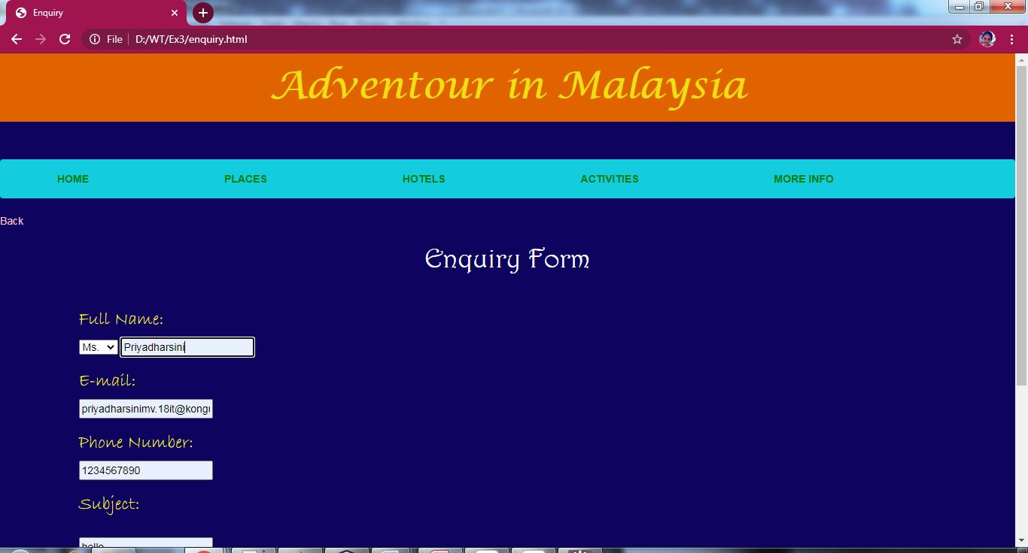

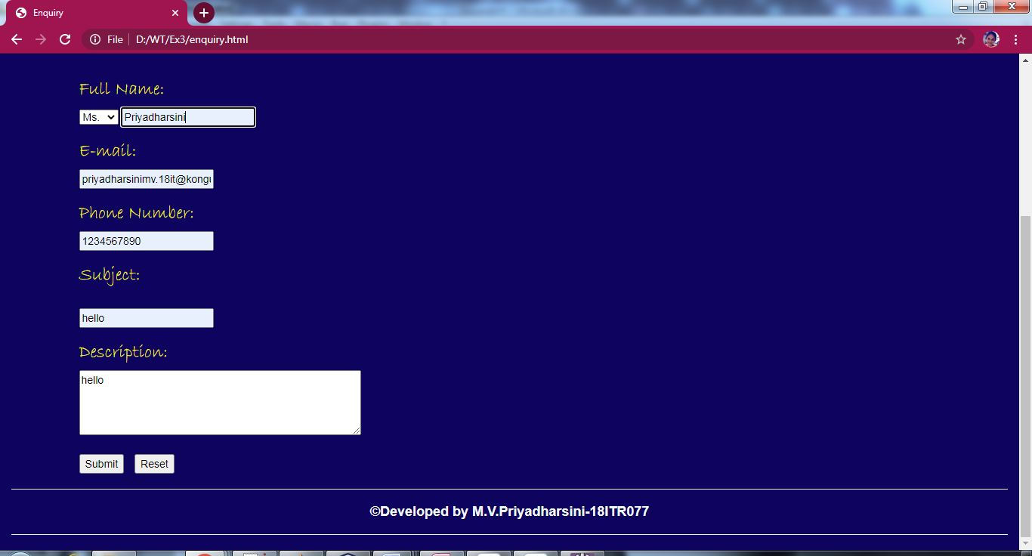

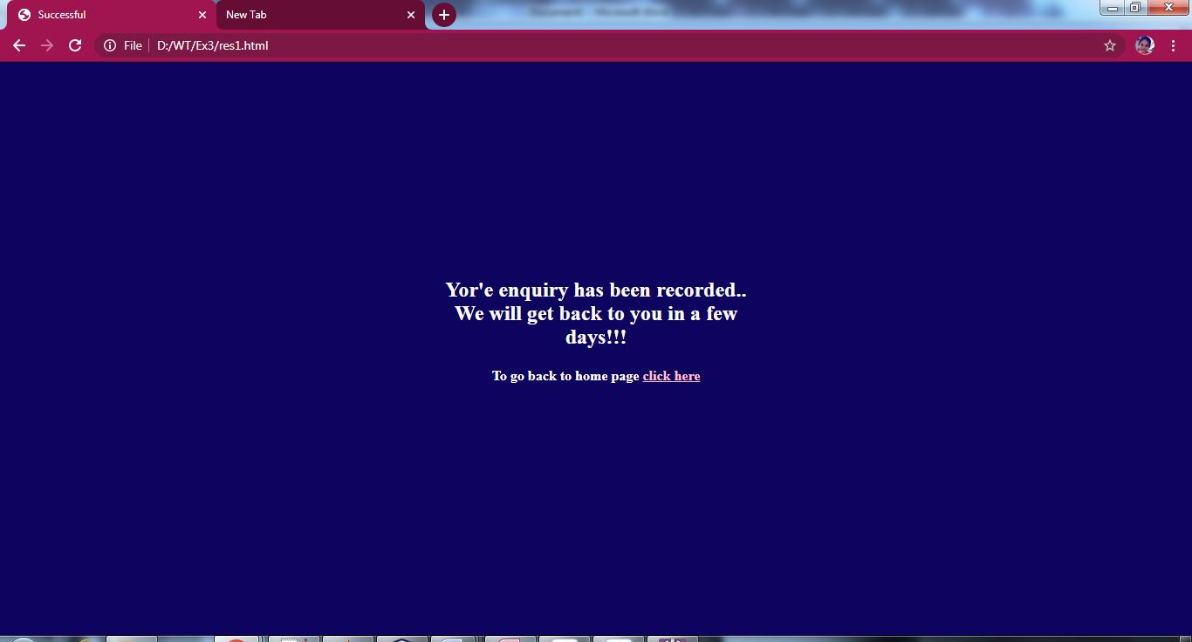

**Feedback.html**

<!DOCTYPE html>

<html lang="en">

<head>

<meta charset="utf-8">

<meta name="viewport" content="width=device-width, initial-scale=1">

<link rel="stylesheet" href="https://maxcdn.bootstrapcdn.com/bootstrap/3.4.1/css/bootstrap.min.css">

<script src="https://ajax.googleapis.com/ajax/libs/jquery/3.5.1/jquery.min.js"></script>

<script src="https://maxcdn.bootstrapcdn.com/bootstrap/3.4.1/js/bootstrap.min.js"></script>

<link rel="stylesheet"type="text/css"href="h41.css"/>

<link rel="stylesheet"type="text/css"href="h1.css"/>

<link rel="stylesheet"type="text/css"href="h3.css"/>

<link rel="stylesheet"type="text/css"href="h2.css"/>

<link rel="stylesheet"type="text/css"href="a1.css"/>

<link rel="stylesheet"type="text/css"href="jumbotron.css"/>

<link rel="stylesheet"type="text/css"href="body.css"/>

<title>Feedback</title>

<style>

p{

color:white;

}

a:link {

color: #996515;

}

a:visited {

color: green;

}

a:hover {

color: red;

}

a:active {

color: yellow;

}

.navbar-custom{

background-color:#13CDDF;

}

.navbar-nav > li{

padding-left:30px;

padding-right:120px;

}

</style>

</head>

<body>

<div class="jumbotron text-center">Adventour in Malaysia</div><br>

<nav class="navbar navbar navbar-custom">

<div class="container-fluid">

<div class="navbar-header">

<button type="button" class="navbar-toggle" data-toggle="collapse" data-target="#myNavbar">

<span class="icon-bar"></span>

<span class="icon-bar"></span>

<span class="icon-bar"></span>

</button>

</div>

<div class="collapse navbar-collapse" id="myNavbar">

<ul class="nav navbar-nav">

<li><a href="index.html"><b>HOME</b></a></li>

<li><a href="places.html"><b>PLACES</b></a></li>

<li><a href="hotels.html"><b>HOTELS</b></a></li>

<li><a href="activities.html"><b>ACTIVITIES</b></a></li>

<li><a href="info.html"><b>MORE INFO</b></a></li>

</ul>

</div>

</div>

</nav>

<a href="index.html" style="color:pink">Back</a>

<h1><center>Feedback Form</center></h1><br>

<div class="container">

<div class="row">

<div class="col-md-12">

<p>We would love to hear your thoughts,concerns or problem with anything so we can improve!</p>

<form method="post" action="res2.html">

<fieldset>

<h3>

Full Name:</h3>

<span style="width:110px"></span>

<select id = "salutation" style="color:black">

<option value = "Mr.">Mr.</option>

<option value = "Ms.">Ms.</option>

<option value = "Mrs.">Mrs.</option>

<option value = "Dr.">Dr.</option>

</select>

<input type="text" id="fname" name="fname" required style="color:black"><br><br>

<h3>E-mail:</h3><span style="width:140px"></span>

<input type="email" id="email" name="email" placeholder="abc@gmail.com" required style="color:black"><br><br>

<h3>Phone Number:</h3><span style="width:80px"></span>

<input type="tel" id="tel" name="tel" pattern="[0-9]{10}" placeholder="Should contain 10 digits" required style="color:black"><br><br>

<h3>Descriptive Feedback:</h3><span style="width:30px"></span>

<textarea rows="4" cols="50" required style="color:black"></textarea><br><br>

<input type="submit" value="Submit" style="color:black"/>&ensp;&ensp;<input type="reset" value="Reset" style="color:black"/><br>

</h3>

</fieldset>

</form>

</div>

</div>

</div>

<div class="col-md-12"><hr>

<h4><center><b>&copy;Developed by M.V.Priyadharsini-18ITR077</b></center></h4><hr>

</div>

</body>

</html>

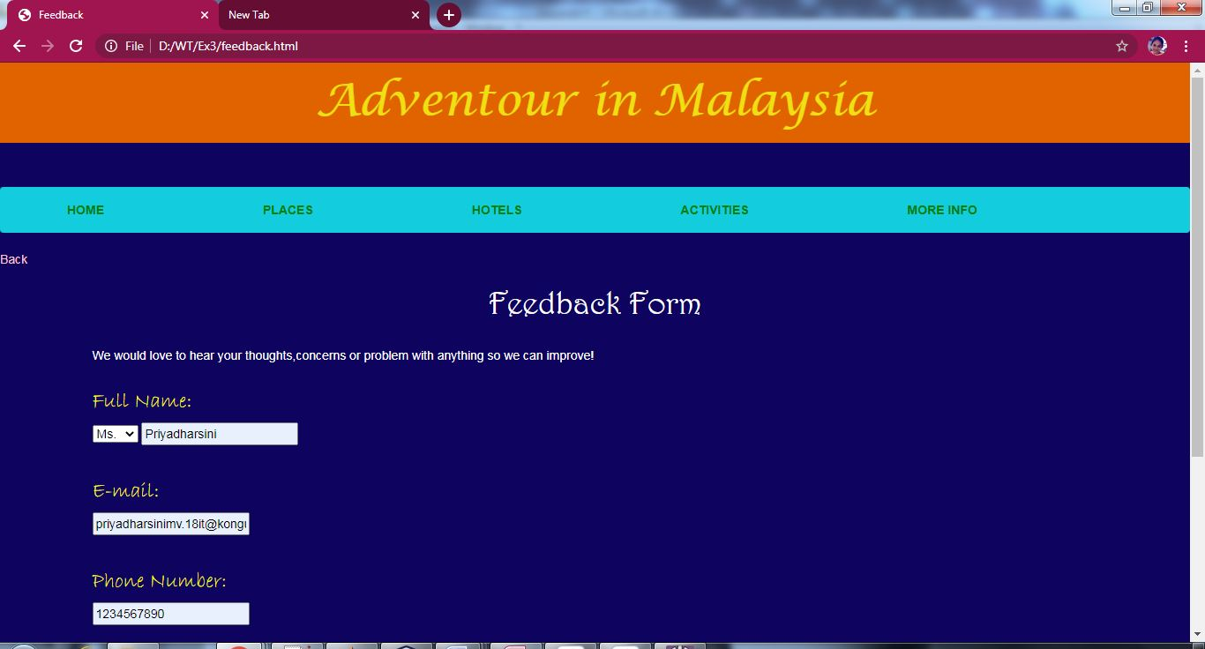

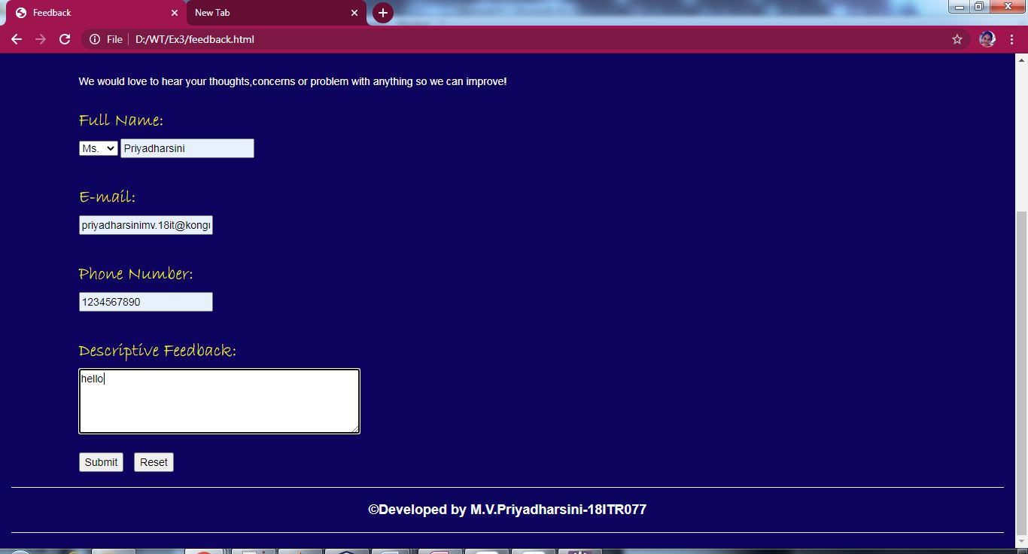

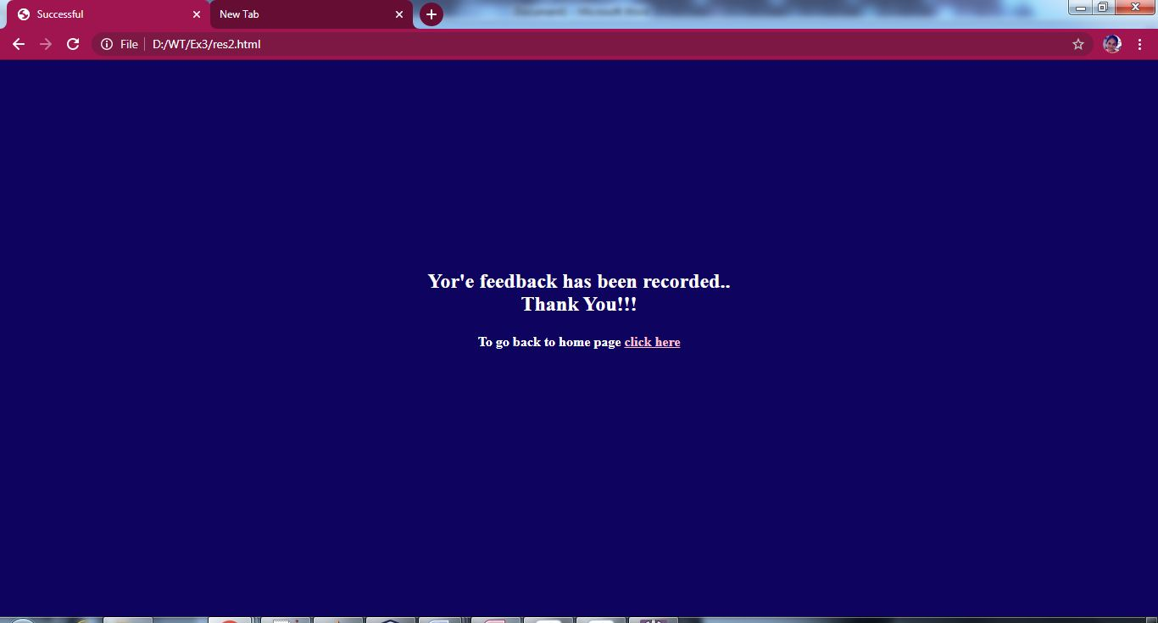

**Places.html**

<!DOCTYPE html>

<html lang="en">

<head>

<meta charset="utf-8">

<meta name="viewport" content="width=device-width, initial-scale=1">

<link rel="stylesheet" href="https://maxcdn.bootstrapcdn.com/bootstrap/3.4.1/css/bootstrap.min.css">

<script src="https://ajax.googleapis.com/ajax/libs/jquery/3.5.1/jquery.min.js"></script>

<script src="https://maxcdn.bootstrapcdn.com/bootstrap/3.4.1/js/bootstrap.min.js"></script>

<link rel="stylesheet"type="text/css"href="h41.css"/>

<link rel="stylesheet"type="text/css"href="jumbotron.css"/>

<link rel="stylesheet"type="text/css"href="h2.css"/>

<link rel="stylesheet"type="text/css"href="a1.css"/>

<link rel="stylesheet"type="text/css"href="body.css"/>

<link rel="stylesheet"type="text/css"href="h1.css"/>

<style>

a:link {

color: #996515;

}

a:visited {

color: green;

}

a:hover {

color: red;

}

a:active {

color: yellow;

}

.navbar-custom{

background-color:#13CDDF;

}

.navbar-nav > li{

padding-left:30px;

padding-right:120px;

}

</style>

<title>Places to go</title>

</head>

<body>

<a href="index.html" style="color:pink">Back</a><br>

<div class="jumbotron text-center">Adventour in Malaysia</div><br>

<nav class="navbar navbar navbar-custom">

<div class="container-fluid">

<div class="navbar-header">

<button type="button" class="navbar-toggle" data-toggle="collapse" data-target="#myNavbar">

<span class="icon-bar"></span>

<span class="icon-bar"></span>

<span class="icon-bar"></span>

</button>

</div>

<div class="collapse navbar-collapse" id="myNavbar">

<ul class="nav navbar-nav">

<li><a href="index.html"><b>HOME</b></a></li>

<li><a href="places.html"><b>PLACES</b></a></li>

<li><a href="hotels.html"><b>HOTELS</b></a></li>

<li><a href="activities.html"><b>ACTIVITIES</b></a></li>

<li><a href="info.html"><b>MORE INFO</b></a></li>

</ul>

</div>

</div>

</nav>

<h1><center>PLACES TO GO</center></h1>

<div class="container">

<div class="row">

<div class="col-md-4"><a href="genting.html"><img src="genting.jpg" width="100%" height="225px"/></a><h2><b>Genting Highlands</b></h2></div>

<div class="col-md-4"><a href="petrona.html"><img src="petrona.jpg" width="100%" /></a><h2><b>Petronas Towers</b></h2></div>

<div class="col-md-4"><a href="batucaves.html"><img src="batucaves.jpg" width="100%"/></a><h2><b>Batu Caves</b></h2></div>

</div>

</div>

<br>

<div class="container">

<div class="row">

<div class="col-md-4"><a href="perhentian.html"><img src="perhentian.jpg" width="100%" height="240px"/></a><h2><b>Perhentian Islands</b></h2></div>

<div class="col-md-4"><a href="kinabalu.html"><img src="kinabalu.jpg" width="100%" /></a><h2><b>Mount kinabalu</b></h2></div>

<div class="col-md-4"><a href="aquaria.html"><img src="aquaria.jpg" width="100%" height="240px"/></a><h2><b>Aquaria KLCC</b>/h2></div>

</div>

</div>

<div class="row">

<div class="col-sm-12">

<hr><h4><center><b>&copy;Developed by M.V.Priyadharsini-18ITR077</b></center></h4><hr>

</div>

</div>

</body>

</html>

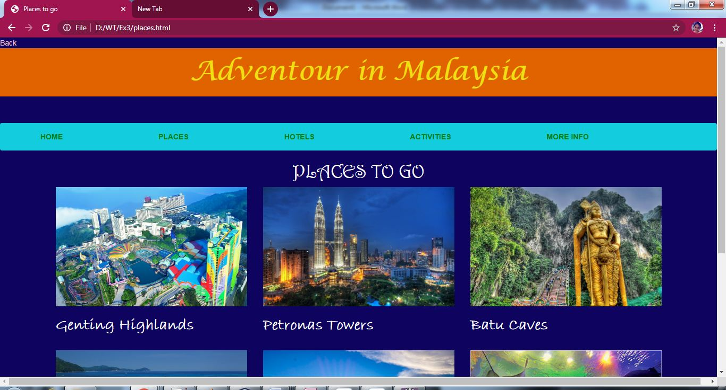

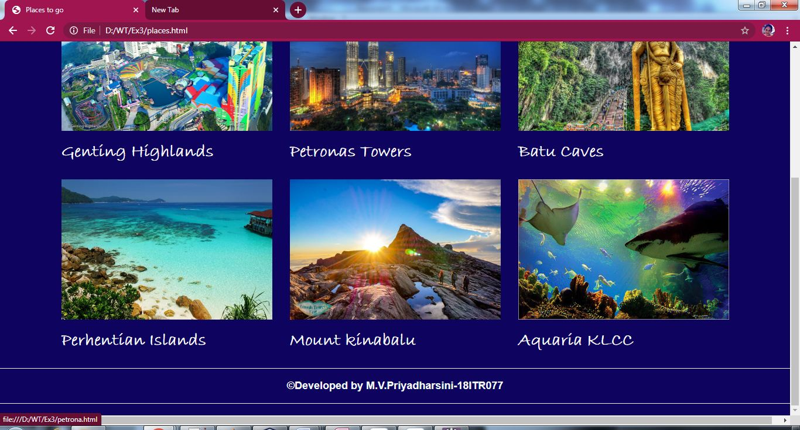

**Genting.html:**

<html>

<head>

<link rel="stylesheet"type="text/css"href="body.css"/>

<link rel="stylesheet"type="text/css"href="h1.css"/>

<link rel="stylesheet"type="text/css"href="a1.css"/>

<link rel="stylesheet"type="text/css"href="h31.css"/>

<link rel="stylesheet"type="text/css"href="ul.css"/>

<link rel="stylesheet"type="text/css"href="ol.css"/>

<style>

h1{

color:yellow;

}

</style>

<title>Genting Highlands</title>

</head>

<body bgcolor="#0E035F">

<p id="t"></p>

<a href="places.html" style="color:pink">Back</a>

<h1><center>Genting Highlands</center></h1>

<hr>

<a href="#b">Go to Bottom</a>

<p><h4><b><em>&emsp;&emsp;Resorts World Genting originally known as Genting Highlands Resort is an integrated hill resort development comprising hotels, shopping malls, theme parks and casinos, perched on the peak of Mount Ulu Kali at 1,800 meters elevation near the border between the states of Pahang and Selangor, Malaysia.

The integrated hill resort is accessible by car within an hour's drive from Kuala Lumpur (about 35 km), or accessible by two different cable cars, Genting Skyway which at its opening was the world's fastest and South East Asia's longest gondola lift, and the newer Awana Skyway.</em></b></h3></p>

<h3><ins>Attractions</ins></h3>

<ul type="square">

<li><h4>Theme parks</h4></li><br>

<img src="park.jpg" height="300px" width="500px"/>

<li><h4>Casinos</h4></li><br>

<img src="casino.jpg" height="300px" width="500px"/>

<li><h4>Amenities</h4></li>

<ol>

<li>Arena of Stars is a concert hall with a capacity of 5,132 seats</li>

<li>Genting International Showroom is a multimedia entertainment venue with up to 1,000 seating capacity.</li>

<li>Bona Cinemas at SkyAvenue is their first cineplex outside China and consists of 6 cinema halls equipped with Dolby Atmos sound systems and IMAX theatre systems</li>

<br>

<img src="arena.jpg" height="300px" width="500px"/>

</ol>

</ul>

<p id="b"></p>

<a href="#t">Go to Top</a>

</body>

</html>

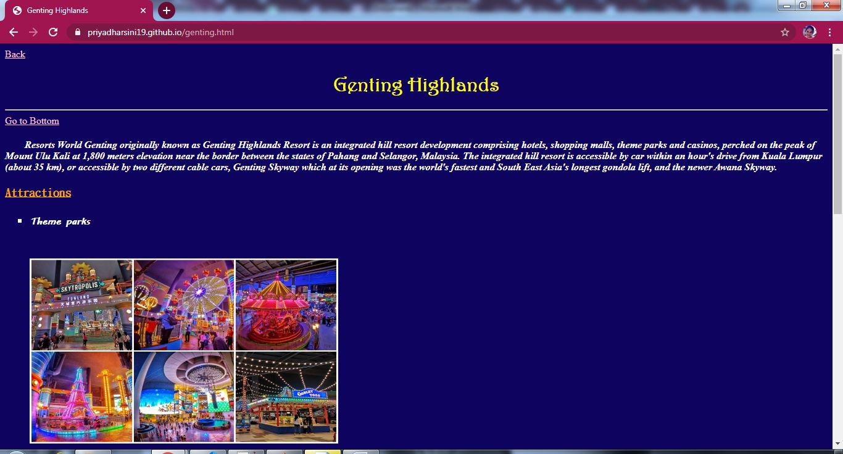

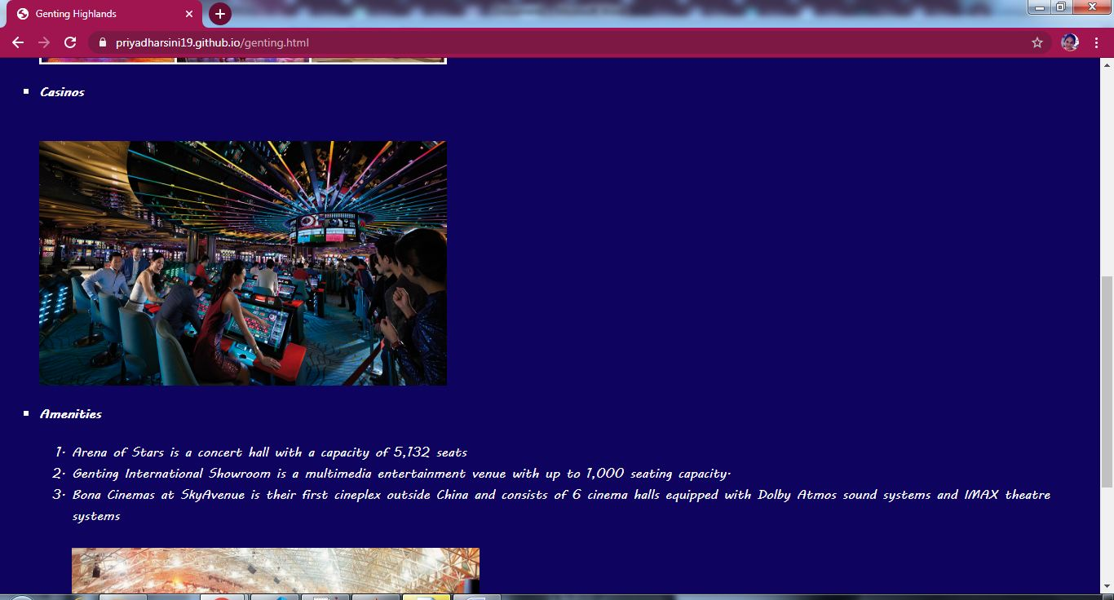

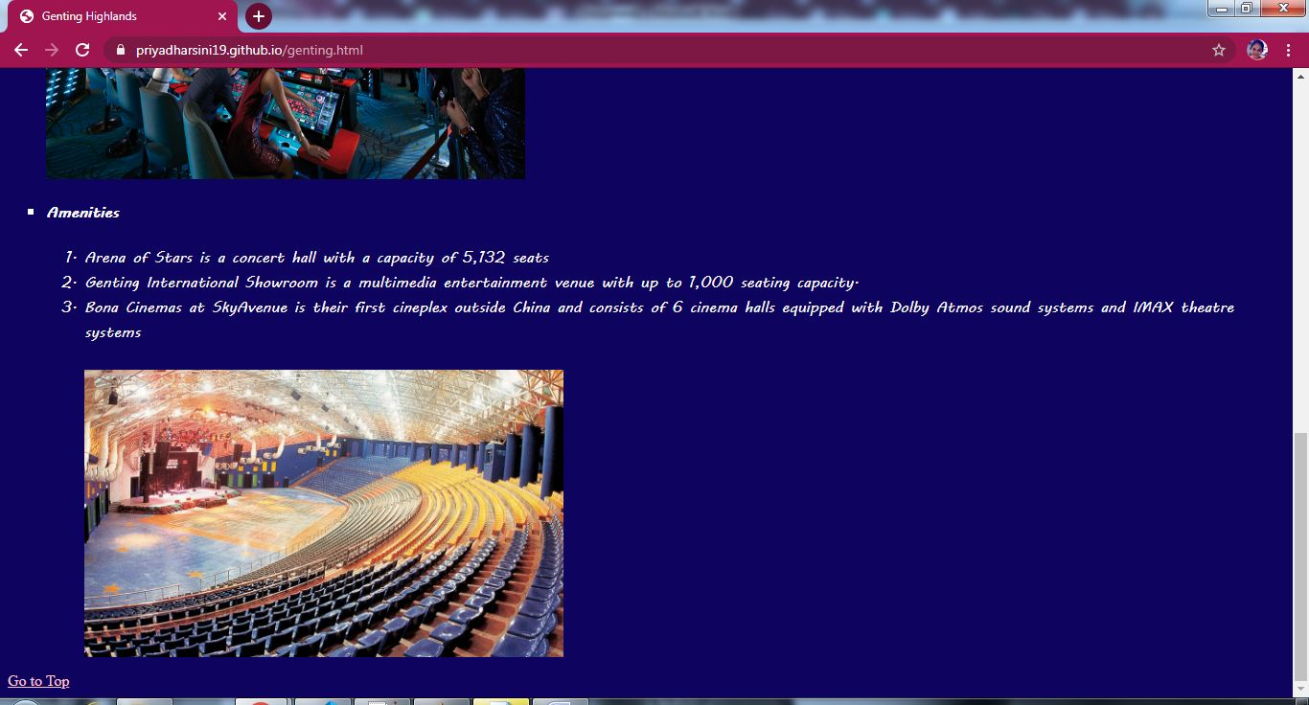

**Petrona.html:**

<html>

<head>

<link rel="stylesheet"type="text/css"href="body.css"/>

<link rel="stylesheet"type="text/css"href="h1.css"/>

<link rel="stylesheet"type="text/css"href="a1.css"/>

<link rel="stylesheet"type="text/css"href="h31.css"/>

<link rel="stylesheet"type="text/css"href="ul.css"/>

<style>

h1{

color:yellow;

}

</style>

<title>Petronas Twin Towers</title>

</head>

<body bgcolor="#0E035F">

<p id="t"></p>

<a href="places.html" style="color:pink">Back</a>

<h1><center>Petronas Twin Towers</center></h1>

<hr>

<a href="#b">Go to Bottom</a>

<p><h4><b><em>&emsp;&emsp;The Petronas Towers, also known as the Petronas Twin Towers (Malay: Menara Petronas, or Menara Berkembar Petronas), are twin skyscrapers in Kuala Lumpur, Malaysia. According to the Council on Tall Buildings and Urban Habitat (CTBUH)'s official definition and ranking, they were the tallest buildings in the world from 1998 to 2004, until they were surpassed by Taipei 101. The Petronas Towers remain the tallest twin towers in the world.

The buildings are a landmark of Kuala Lumpur, along with nearby Kuala Lumpur Tower; they remain the tallest buildings in Kuala Lumpur.The tower has about 88(+5 below ground)floors in it.</em></b></h4></p>

<h3><ins>Attractions</ins></h3>

<ul>

<li><h4>Suria KLCC</h4></li><br>

<img src="suria.jpg" height="300px" width="500px"/>

<li><h4>KLCC park</h4></li><br>

<img src="klcc.jpg" height="300px" width="500px"/>

<li><h4>Skybridge</h4></li>

<img src="bridge.jpg" height="300px" width="500px"/>

</ul>

<p id="b"></p>

<a href="#t">Go to Top</a>

</body>

</html>

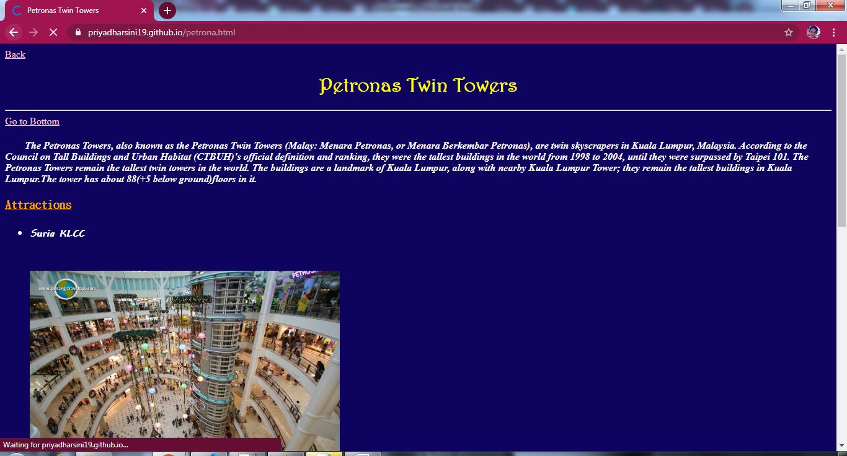

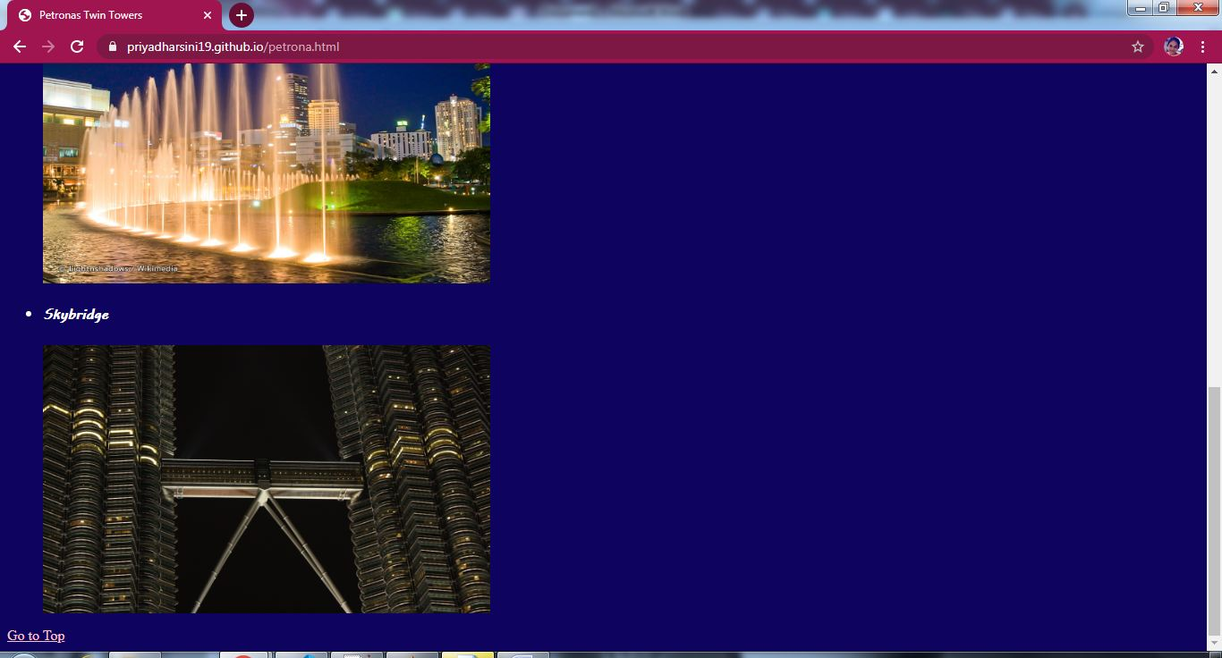

**Batucaves.html:**

<html>

<head>

<link rel="stylesheet"type="text/css"href="body.css"/>

<link rel="stylesheet"type="text/css"href="h1.css"/>

<link rel="stylesheet"type="text/css"href="a1.css"/>

<link rel="stylesheet"type="text/css"href="h31.css"/>

<style>

h1{

color:yellow;

}

</style>

<title>Batu Caves</title>

</head>

<body bgcolor="#0E035F">

<p id="t"></p>

<a href="places.html" style="color:pink">Back</a>

<h1><center>Batu Caves</center></h1>

<hr>

<a href="#b">Go to Bottom</a>

<p><h4><b><em>&emsp;&emsp;Batu Caves is a limestone hill that has a series of caves and cave temples in Gombak, Selangor, Malaysia. It takes its name from the Malay word batu, meaning 'rock'.Batu Caves is also the name of a nearby town.

The cave is one of the most popular Hindu shrines outside India, and is dedicated to Lord Murugan. It is the focal point of the Hindu festival of Thaipusam in Malaysia.

Batu Caves in short also referred as 10th Caves or Hill for Lord Muruga as there are six important holy shrines in India and four more in Malaysia. The three others in Malaysia are Kallumalai Temple in Ipoh, Tanneermalai Temple in Penang and Sannasimalai Temple in Malacca.</em></b></h4></p>

<ul>

<li><h3><ins>Rock climbing</ins></h3></li>

<center><img src="rock.jpg" height="300px" width="500px"/></center>

<p><h4><b><em>&emsp;&emsp;Batu Caves is also the centre of rock climbing development in Malaysia for the past 10 years. Batu Caves offers more than 160 climbing routes.The routes are scattered all around the side of Batu Caves, which is made up of limestone hills rising to 150 m. These climbing routes are easily accessed, as most crags start from ground level.These climbing routes often start from the North Eastern side of the cave complex whereas the staircase and temple entrance faces South. This Northeastern area is known as the Damai caves. Abseiling and spelunking trips can be organised with some local adventure companies</em></b></h4></p>

<li><h3><ins>Festivals</ins></h3></li>

<center><img src="fes.jpg" height="300px" width="500px"/></center>

<p><h4><b><em>&emsp;&emsp;The Batu Caves serve as the focus of the Hindu community's yearly Thaipusam festival. They have become a pilgrimage site not only for Malaysian Hindus, but Hindus worldwide.

A procession begins in the wee hours of the morning on Thaipusam from the Sri Mahamariamman Temple, Kuala Lumpur leading up to Batu Caves as a religious undertaking to Lord Muruga lasting eight hours. Devotees carry containers containing milk as offering to Lord Murugan either by hand or in huge decorated carriers on their shoulders called 'kavadi'.</em></b></h4></p>

<p id="b"></p>

<a href="#t">Go to Top</a>

</body>

</html>

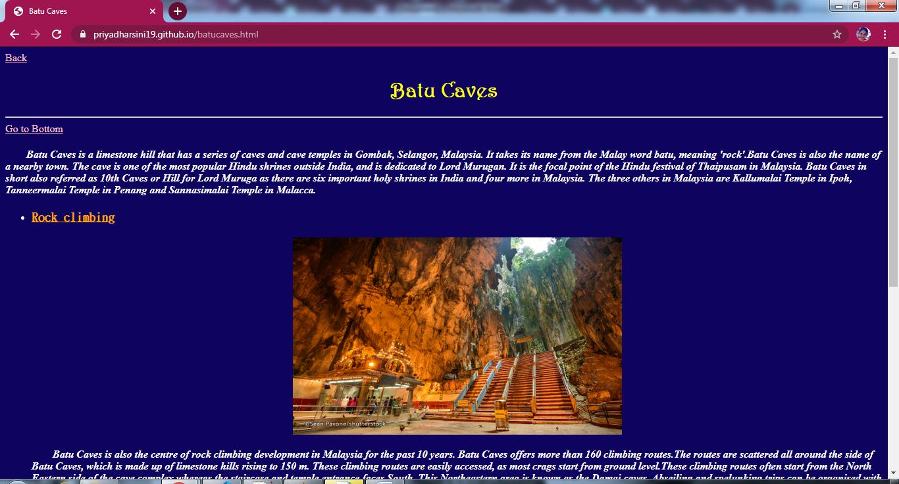

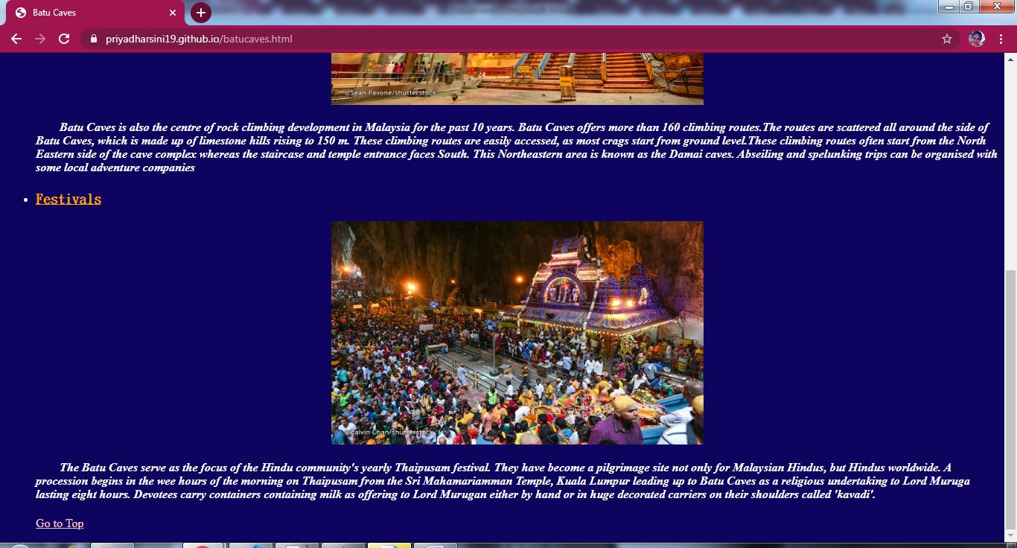

**Perhentian.html:**

<html>

<head>

<link rel="stylesheet"type="text/css"href="body.css"/>

<link rel="stylesheet"type="text/css"href="h1.css"/>

<link rel="stylesheet"type="text/css"href="a1.css"/>

<link rel="stylesheet"type="text/css"href="h31.css"/>

<style>

h1{

color:yellow;

}

</style>

<title>Perhentian Islands</title>

</head>

<body bgcolor="#0E035F">

<p id="t"></p>

<a href="places.html" style="color:pink">Back</a>

<h1><center>Perhentian Islands</center></h1>

<hr>

<a href="#b">Go to Bottom</a>

<p><h4><b><em>&emsp;&emsp;The Perhentian Islands (Malay: Kepulauan Perhentian) are islands in Besut District, Terengganu, Malaysia.

The two main islands are Perhentian Besar ("Greater Perhentian") and Perhentian Kecil ("Lesser Perhentian"). The small, uninhabited islands of Susu Dara (Virgin Milk), Serengeh and Rawa lie off Kecil.

Like Besut, people here generally speak Kelantanese Malay, however English is widely spoken and understood to accommodate the growing tourism market. The Perhentian Islands have become a popular travel destination for families and backpackers alike due to the many lodging options that accommodate almost any budget.</em></b></h4></p>

<ul>

<li><h3><ins>Besar and Kecil</ins></h3></li>

<center><img src="besar.jpg" height="300px" width="500px"/></center>

<p><h4><b><em>&emsp;&emsp;Nature tourism provides the economic base for the islands. Both the islands have palm-fringed white coral sand beaches (that can be tough on the feet) and turquoise blue sea. Popular tourist activities include scuba-diving, snorkeling, and swimming. On most beaches, the water is shallow with many rays, cuttlefish and parrotfish. For diving, there are dozens of dive sites around both main islands, as well as several off-shore sites. Apart from these, activities like camping, canoeing, fishing, jungle trekking, and banana boat riding are also available.</em></b></h4></p>

<li><h3><ins>Climate</ins></h3></li>

<p><h4><b><em>&emsp;&emsp;The Perhentian islands experience a heavy monsoon season between November and February, and most of the islands are essentially closed off to tourists. Resorts and ferry services are stopped during this time due to the weather but there is still a boat service daily to serve the fishermen village at Pulau Perhentian Kecil. On average each year, the Perhentian Islands receive over 100 inches of rain and experiences roughly 12 daylight hours on average. January: 82 February: 84 March: 86 April: 90 May: 90 June: 90 July: 88 August: 88 September: 88 October: 86 November: 84 December: 82 </em></b></h4></p>

<li><h3><ins>Turtle conservation</ins></h3></li>

<p><h4><b><em>&emsp;&emsp;The Perhentian Islands were once home to a significant green and hawksbill sea turtle nesting population. The Department of Fisheries runs a turtle hatchery on the islands to help address the declining turtle populations. Egg poaching from the beaches is a continuing problem.</em></b></h4></p>

<p id="b"></p>

<a href="#t">Go to Top</a>

</body>

</html>

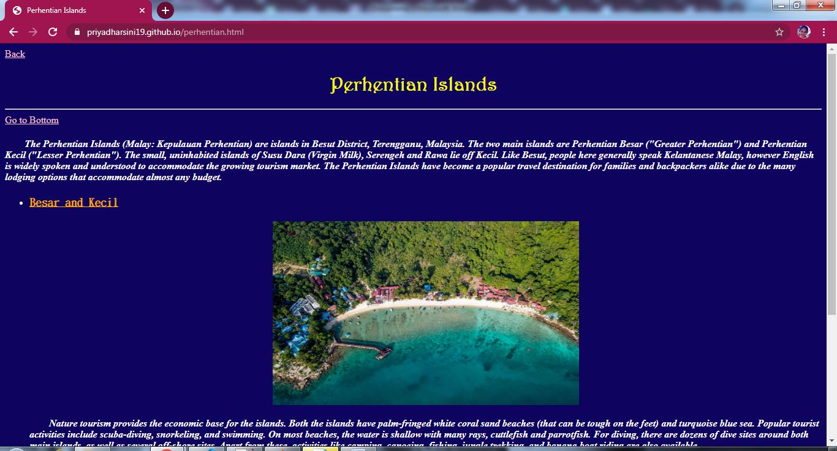

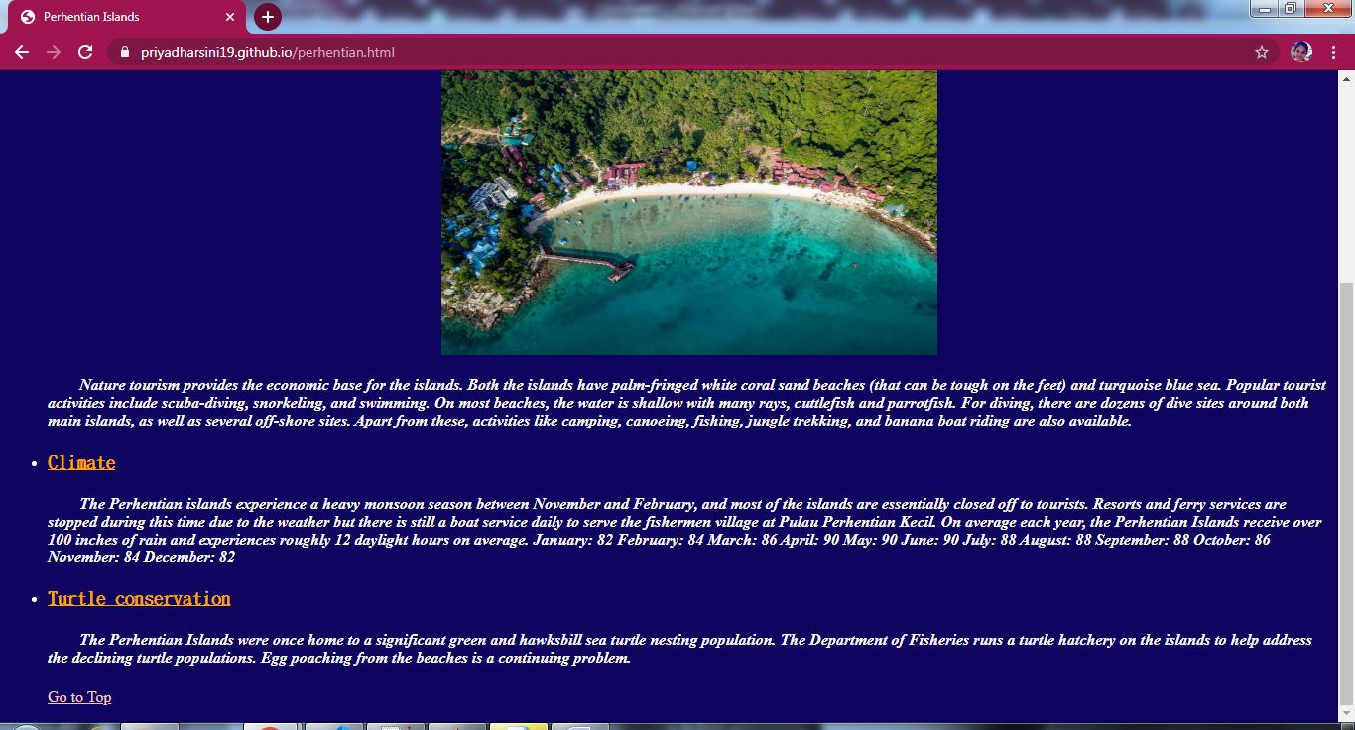

**Kinabalu.html:**

<html>

<head>

<link rel="stylesheet"type="text/css"href="body.css"/>

<link rel="stylesheet"type="text/css"href="h1.css"/>

<link rel="stylesheet"type="text/css"href="a1.css"/>

<link rel="stylesheet"type="text/css"href="h31.css"/>

<style>

h1{

color:yellow;

}

</style>

<title>Mount kinabalu</title>

</head>

<body bgcolor="#0E035F">

<p id="t"></p>

<a href="places.html" style="color:pink">Back</a>

<h1><center>Mount kinabalu</center></h1>

<hr>

<a href="#b">Go to Bottom</a>

<p><h4><b><em>&emsp;&emsp;Mountain Kinabalu (Malay: Gunung Kinabalu) (Dusun: Gayo Ngaran or Nulu Nabalu) is a mountain located at the West Coast Division of Sabah, Malaysia. It is protected as Kinabalu Park, a World Heritage Site. Kinabalu is the highest peak in Borneo's Crocker Range and is the highest mountain in the Malay Archipelago as well as the highest mountain in Malaysia.Mount Kinabalu is also the 20th most prominent mountain in the world by topographic prominence.Mount Kinabalu includes the Kinabalu montane alpine meadows ecoregion in the montane grasslands and shrublands biome. The mountain and its surroundings are among the most important biological sites in the world, with between 5,000 and 6,000 species of plants, 326 species of birds, and more than 100 mammalian species identified.</em></b></h4></p>

<ul>

<li><h3><ins>Flora</ins></h3></li>

<center><img src="flora.jpg" height="300px" width="500px"/></center>

<p><h4><b><em>&emsp;&emsp;The flora covers the mountain in zones of different types of habitat as one climbs up, beginning with a lowland belt of fig trees and insectivorous pitcher plants. Then between 2,600 to 3,200 m (8,530 to 10,499 ft) is a layer of short trees such the conifer Dacrydium gibbsiae and dwarf shrubs, mosses, lichens, liverworts, and ferns. Finally many of the world's richest variety of orchids are found on the high rockier slopes.These plants have high levels of endemism (i.e. species which are found only within Kinabalu Park and are not found anywhere else in the world). The orchids are the best-known example with over 800 species including some of the highly valued Paphiopedilum slipper orchids, but there are also over 600 species of ferns (more than the whole of Africa's 500 species) of which 50 are found nowhere else, and the richest collection in the world for the Nepenthes pitcher plants (five of the thirteen are found nowhere else on earth) which reach spectacular proportions (the largest-pitchered in the world being the endemic Nepenthes rajah)</em></b></h4></p>

<li><h3><ins>Fauna</ins></h3></li>

<center><img src="fauna.jpg" height="300px" width="500px"/></center>

<p><h4><b><em>&emsp;&emsp;The variety of plant life is also habitat for a great variety of birds and mammals.There are some 326 species of birds in Kinabalu Park, including the spectacular rhinoceros hornbill, mountain serpent-eagle, Dulit frogmouth, eyebrowed jungle flycatcher, and bare-headed laughingthrush. Twenty-four birds are mainly found on the mountain. The mountain is home to some 100 mammalian species mostly living high in the trees, including one of the four great apes, the orangutan (though sightings of these are uncommon; estimates of its numbers in the park range from 25 to 120).[2] Other mammals include three kinds of deer, the Malayan weasel (Mustela nudipes), oriental small-clawed otter (Aonyx cinerea), and leopard cat (Felis bengalensis). Endemic mammals include the black shrew (Suncus ater).</em></b></h4></p>

<li><h3><ins>Threats and preservation</ins></h3></li>

<p><h4><b><em>&emsp;&emsp;The steep mountainsides with poor soil are not suitable for farming or for the timber industry so the habitats and animal life of Kinabalu remain largely intact, with about a third of the original habitat now degraded. Kinabalu Park was established in 1964 and the nearby mountains were protected as the Crocker Range National Park in 1984. However even national park status does not guarantee full protection, as logging permits were granted on Trus Madi in 1984.Climate Change is likely to reduce the suitable habitat for cold-adapted species from the montane habitats</em></b></h4></p>

<p id="b"></p>

<a href="#t">Go to Top</a>

</body>

</html>

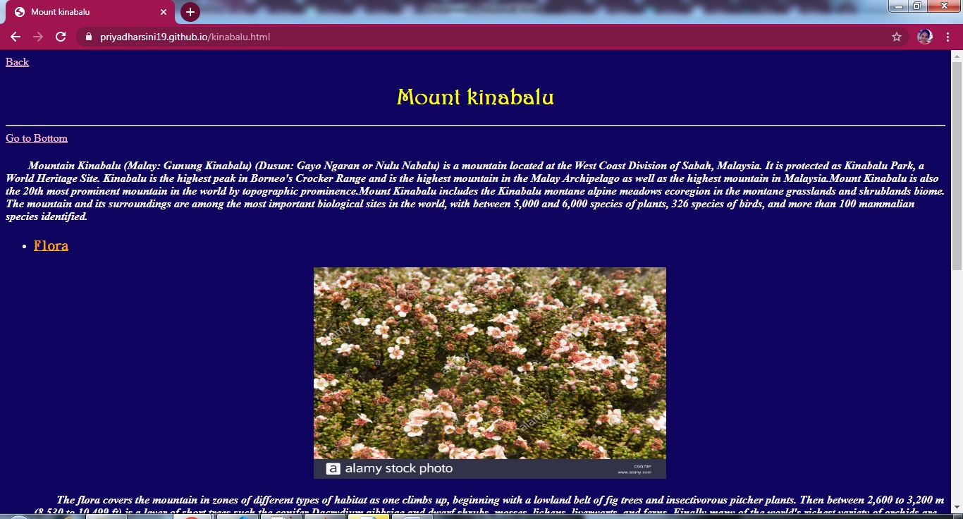

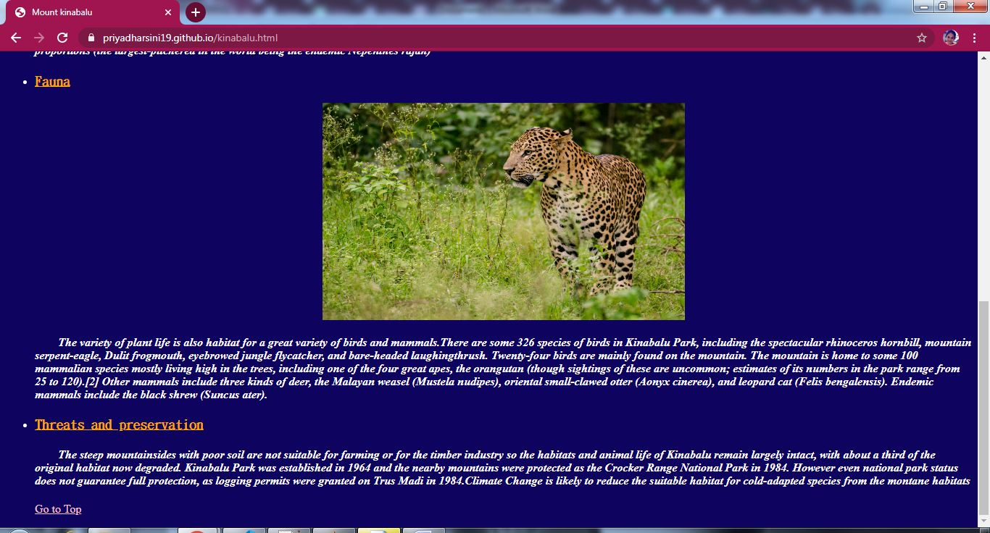

**Aquaria.html:**

<html>

<head>

<link rel="stylesheet"type="text/css"href="body.css"/>

<link rel="stylesheet"type="text/css"href="h1.css"/>

<link rel="stylesheet"type="text/css"href="a1.css"/>

<link rel="stylesheet"type="text/css"href="h31.css"/>

<link rel="stylesheet"type="text/css"href="ul.css"/>

<style>

h1{

color:yellow;

}

</style>

<title>Aquaria KLCC</title>

</head>

<body bgcolor="#0E035F">

<p id="t"></p>

<a href="places.html" style="color:pink">Back</a>

<h1><center>Aquaria KLCC</center></h1>

<hr>

<a href="#b">Go to Bottom</a>

<p><h4><b><em>&emsp;&emsp;The Aquaria KLCC is an oceanarium located beneath Kuala Lumpur Convention Centre within Kuala Lumpur City Centre in Kuala Lumpur, Malaysia.Featuring 60,000 square feet (5,600 m2) in two levels with a 90-metre (300 ft) underwater tunnel, Aquaria KLCC houses over 250 different species and over 5,000 land and aquatic animals from Malaysia and around the world. Interactive information kiosks on fish and turtle conservation. It includes a themed retail area of about 5,000 square feet (460 m2). Aquaria KLCC is based on the journey of water from the land to the sea. The journey starts in the misty highlands, down through rivers, through the rainforest and mangroves to the coral reefs into the deep blue sea.</em></b></h3></p>

<h3><ins>Exhibits</ins></h3>

<center><img src="aqu.jpg" height="300px" width="500px"/></center>

<ul type="square">

<li><h4>Evolution zone</h4></li>

<li><h4>Touch pool</h4></li>

<li><h4>Jewels of jungle</h4></li>

<li><h4>Ship wreck</h4></li>

<li><h4>The stream</h4></li>

<li><h4>Deep forest</h4></li>

<li><h4>Flooded forest</h4></li>

<li><h4>The coastal</h4></li>

<li><h4>Living ocean</h4></li>

<li><h4>wierd and wonderful</h4></li>

</ul>

<h3><ins>Experience</ins></h3>

<center><img src="cage.jpg" height="300px" width="500px"/></center>

<ul type="square">

<li><h4>Cage rage</h4></li>

<li><h4>Dive with Shark</h4></li>

<li><h4>Sleep with Shark</h4></li>

<li><h4>Discovery Hunt</h4></li>

<li><h4>Marriage Proposal</h4></li>

</ul>

<p id="b"></p>

<a href="#t"">Go to Top</a>

</body>

</html>

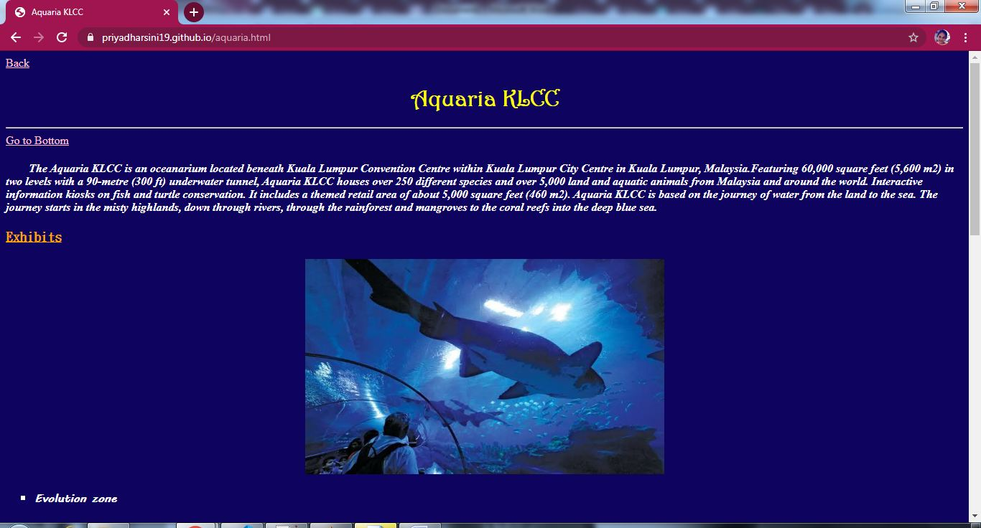

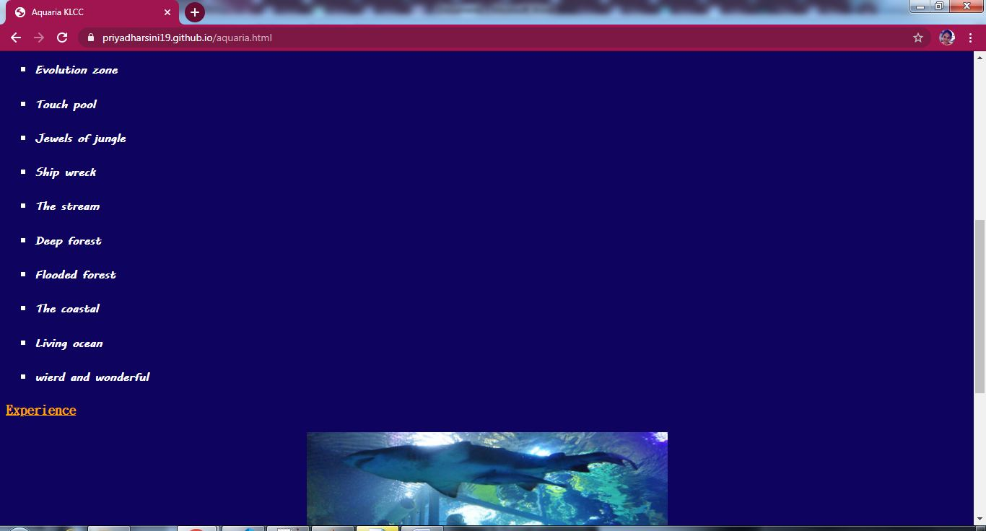

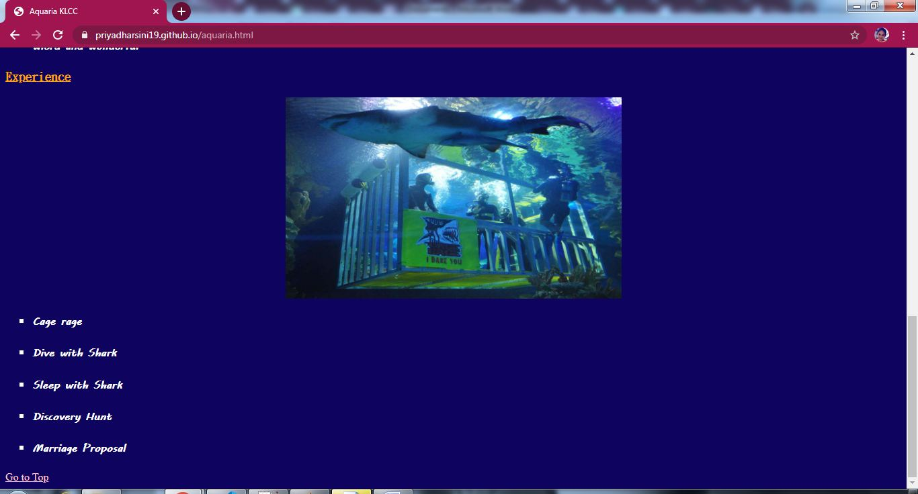

**Hotels.html**

<!DOCTYPE html>

<html lang="en">

<head>

<meta charset="utf-8">

<meta name="viewport" content="width=device-width, initial-scale=1">

<link rel="stylesheet" href="https://maxcdn.bootstrapcdn.com/bootstrap/3.4.1/css/bootstrap.min.css">

<script src="https://ajax.googleapis.com/ajax/libs/jquery/3.5.1/jquery.min.js"></script>

<script src="https://maxcdn.bootstrapcdn.com/bootstrap/3.4.1/js/bootstrap.min.js"></script>

<link rel="stylesheet"type="text/css"href="h41.css"/>

<link rel="stylesheet"type="text/css"href="h1.css"/>

<link rel="stylesheet"type="text/css"href="h2.css"/>

<link rel="stylesheet"type="text/css"href="h3.css"/>

<link rel="stylesheet"type="text/css"href="img.css"/>

<link rel="stylesheet"type="text/css"href="body.css"/>

<link rel="stylesheet"type="text/css"href="jumbotron.css"/>

<style>

a:link {

color: #996515;

}

a:visited {

color: green;

}

a:hover {

color: red;

}

a:active {

color: yellow;

}

.navbar-custom{

background-color:#13CDDF;

}

.navbar-nav > li{

padding-left:30px;

padding-right:120px;

}

</style>

<title>Hotels</title>

</head>

<body bgcolor="#0E035F">

<p id="t"></p>

<a href="index.html" style="color:pink">Back</a>

<br>

<div class="jumbotron text-center">Adventour in Malaysia</div><br>

<nav class="navbar navbar navbar-custom">

<div class="container-fluid">

<div class="navbar-header">

<button type="button" class="navbar-toggle" data-toggle="collapse" data-target="#myNavbar">

<span class="icon-bar"></span>

<span class="icon-bar"></span>

<span class="icon-bar"></span>

</button>

</div>

<div class="collapse navbar-collapse" id="myNavbar">

<ul class="nav navbar-nav">

<li><a href="index.html"><b>HOME</b></a></li>

<li><a href="places.html"><b>PLACES</b></a></li>

<li><a href="hotels.html"><b>HOTELS</b></a></li>

<li><a href="activities.html"><b>ACTIVITIES</b></a></li>

<li><a href="info.html"><b>MORE INFO</b></a></li>

</ul>

</div>

</div>

</nav>

<div class="text-right">

<a href="#b" style="color:pink">Go to Bottom</a>

</div>

<h1>&emsp;&emsp;&emsp;&emsp;&emsp;&emsp;&emsp;&emsp;&emsp;&emsp;&emsp;&emsp;&emsp;&emsp;&emsp;&nbsp;HOTELS</h1>

<div class="container">

<div class="row">

<div class="col-md-6"><img src="prestige.jpg" width="80%" height="200px"/><h2>The Prestige hotel,Penang</h2><h3><del>&#36;100/night</del>&emsp;Now &#36;88/night</h3></div>

<div class="col-md-6"><img src="hardrock.jpg" width="80%" height="200px"/><h2>Hard Rock Hotel,Johar</h2><h3><del>&#36;135/night</del>&emsp;Now &#36;100/night</h3></div>

</div>

</div>

<div class="container">

<div class="row">

<div class="col-md-6"><img src="tiarasa.jpg" width="80%" height="200px"/><h2>Tiarasa Escapes,Pahang</h2><h3><del>&#36;160/night</del>&emsp;Now &#36;146/night</h3></div>

<div class="col-md-6"><img src="tanjong.jpg" width="80%" height="200px"/><h2>Tanjong Jara Resort,Terengganu</h2></h2><h3><del>&#36;240/night</del>&emsp;Now &#36;200/night</h3></div>

</div>

</div>

<h1><center>BOTIQUE HOTELS</center></h1>

<div class="container">

<div class="row">

<div class="col-md-6"><img src="ambong.jpg" width="80%" height="200px"/><h2>Ambong-Ambong,Kedah</h2><h3><del>&#36;150/night</del>&emsp;Now &#36;133/night</h3></div>

<div class="col-md-6"><img src="terra.jpg" width="80%" height="200px"/><h2>Terrapurri,Terengganu</h2><h3><del>&#36;180/night</del>&emsp;Now &#36;150/night</h3></div>

<div>

</div>

<div class="container">

<div class="row">

<div class="col-md-6"><img src="majestic.jpg" width="80%" height="200px"/><h2>Majestic,Melaka</h2><h3><del>&#36;170/night</del>&emsp;Now &#36;200/night</h3></div>

<div class="col-md-6"><img src="estadia.jpg" width="80%" height="200px"/><h2>Estadia,Melaka</h2><h3><del>&#36;220/night</del>&emsp;Now &#36;250/night</h3></div>

<center><h1><a href="booking.html" style="color:pink">Book a hotel now!!</a></h1></center>

<p id="b"></p>

<div class="text-right">

<a href="#t" style="color:pink">Go to Top</a>

</div><hr>

<div class="row">

<div class="col-sm-12">

<h4><center><b>&copy;Developed by M.V.Priyadharsini-18ITR077</b></center></h4><hr>

</div>

</div>

</body>

</html>

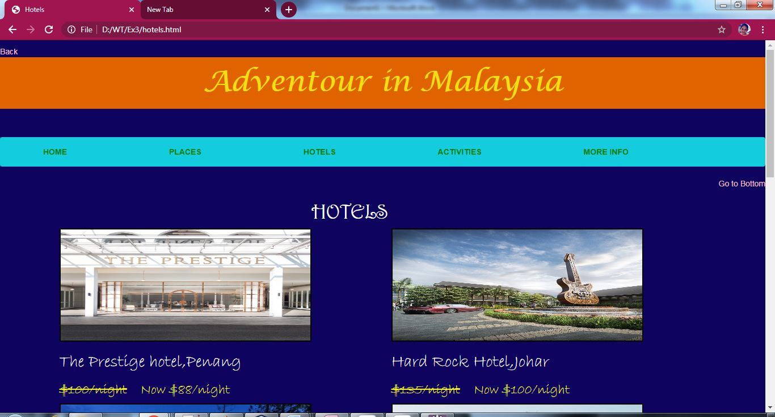

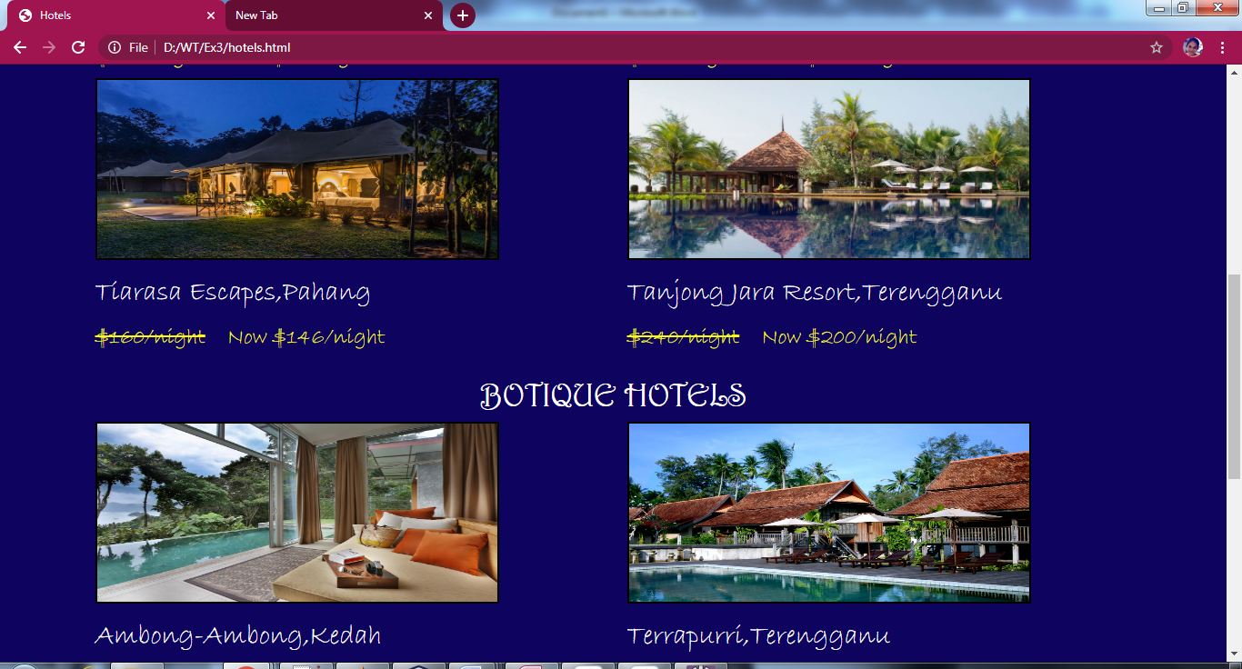

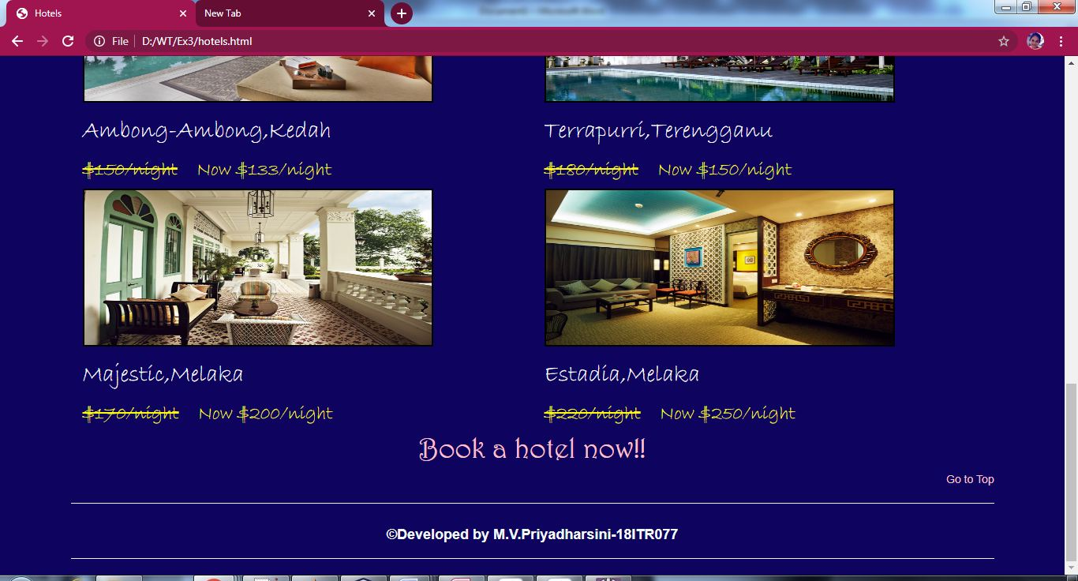

**Booking.html**

<!DOCTYPE html>

<html lang="en">

<head>

<meta charset="utf-8">

<meta name="viewport" content="width=device-width, initial-scale=1">

<link rel="stylesheet" href="https://maxcdn.bootstrapcdn.com/bootstrap/3.4.1/css/bootstrap.min.css">

<script src="https://ajax.googleapis.com/ajax/libs/jquery/3.5.1/jquery.min.js"></script>

<script src="https://maxcdn.bootstrapcdn.com/bootstrap/3.4.1/js/bootstrap.min.js"></script>

<link rel="stylesheet"type="text/css"href="h41.css"/>

<link rel="stylesheet"type="text/css"href="header.css"/>

<link rel="stylesheet"type="text/css"href="rightdiv.css"/>

<link rel="stylesheet"type="text/css"href="nav.css"/>

<link rel="stylesheet"type="text/css"href="nava.css"/>

<link rel="stylesheet"type="text/css"href="footer.css"/>

<link rel="stylesheet"type="text/css"href="a1.css"/>

<link rel="stylesheet"type="text/css"href="h1.css"/>

<link rel="stylesheet"type="text/css"href="span.css"/>

<link rel="stylesheet"type="text/css"href="h3.css"/>

<link rel="stylesheet"type="text/css"href="jumbotron.css"/>

<link rel="stylesheet"type="text/css"href="body.css"/>

<style>

p{

color:white;

}

a:link {

color: #996515;

}

a:visited {

color: green;

}

a:hover {

color: red;

}

a:active {

color: yellow;

}

.navbar-custom{

background-color:#13CDDF;

}

.navbar-nav > li{

padding-left:30px;

padding-right:120px;

}

</style>

<title>Booking</title>

</head>

<body>

<div class="jumbotron text-center">Adventour in Malaysia</div><br>

<nav class="navbar navbar navbar-custom">

<div class="container-fluid">

<div class="navbar-header">

<button type="button" class="navbar-toggle" data-toggle="collapse" data-target="#myNavbar">

<span class="icon-bar"></span>

<span class="icon-bar"></span>

<span class="icon-bar"></span>

</button>

</div>

<div class="collapse navbar-collapse" id="myNavbar">

<ul class="nav navbar-nav">

<li><a href="index.html"><b>HOME</b></a></li>

<li><a href="places.html"><b>PLACES</b></a></li>

<li><a href="hotels.html"><b>HOTELS</b></a></li>

<li><a href="activities.html"><b>ACTIVITIES</b></a></li>

<li><a href="info.html"><b>MORE INFO</b></a></li>

</ul>

</div>

</div>

</nav>

<p><a href="hotels.html" style="color:pink">Back</a></p>

<div class="container">

<div class="row">

<div class="col-md-12">

<h1><center>Please enter the following details to book</center></h1><br>

<form action="res3.html" method="post">

<fieldset>

<h3>

Choose a hotel:</h3>

<input list="hotels" name="hotel" id="hotel" required style="color:black">

<datalist id="hotels">

<option value="The Prestige hotel,Penang">

<option value="Hard Rock Hotel,Johar">

<option value="Ambong-Ambong,Kedah">

<option value="Terrapurri,Terrengganu">

</datalist><br><br>

<h3>Date and time from:</h3>

<input type="datetime-local" id="date" name="date" style="color:black"><br><br>

<h3>Date and time to:</h3>

<input type="datetime-local" id="date" name="date" style="color:black"><br><br>

<h3>No.of people:</h3>

<input type="number" id="people" name="people" style="color:black"><br><br>

<div class="col-sm-3">

<h3>No.of rooms required:</h3>

<input type="range" id="room" name="room" min="0" max="10">

</div>

<div class="container">

<div class="row">

<div class="col-md-12">

<br><br>

<h3>Room type:</h3>

<input type="radio" id="Single" name="room" value = "Single" style="color:black">Single&ensp;&ensp;

<input type="radio" id="Double" name="room" value = "Double" style="color:black">Double&ensp;&ensp;

<input type="radio" id="Triple" name="room" value = "Triple" style="color:black">Triple&ensp;&ensp;

<input type="radio" id="King" name="room" value = "King" style="color:black">King<br>

<input type="radio" id="Queen" name="room" value = "Queen" style="color:black">Queen&ensp;&ensp;

<input type="radio" id="Studio" name="room" value = "Studio" style="color:black">Studio&ensp;&ensp;

<input type="radio" id="Master Suite" name="room" value = "Master Suite" style="color:black">Master Suite&ensp;&ensp;

<input type="radio" id="Mini-Suite" name="room" value = "Mini-Suite" style="color:black">Mini-Suite<br><br>

<h3>Theme of room:</h3>

<input type="color" id="color" name="color" value="#ff0000"><br><br>

<h3>Attach address proof:</h3>

<input type="file" id="myfile" name="myfile"><br><br>

<center><h3>Want to know the average price of rooms?</h3><a href="avgprice.html" style="color:pink">Click here</a></center>

</h3>

<center><input type="submit" value="Submit" style="color:black"/>&ensp;&ensp;<input type="reset" value="Reset" style="color:black"/></center>

</fieldset>

</form>

</div>

</div>

</div>

<br>

<div class="footer">

<hr>

<h4><center><b>&copy;Developed by M.V.Priyadharsini-18ITR077</b></center></h4><hr>

</div>

</body>

</html>

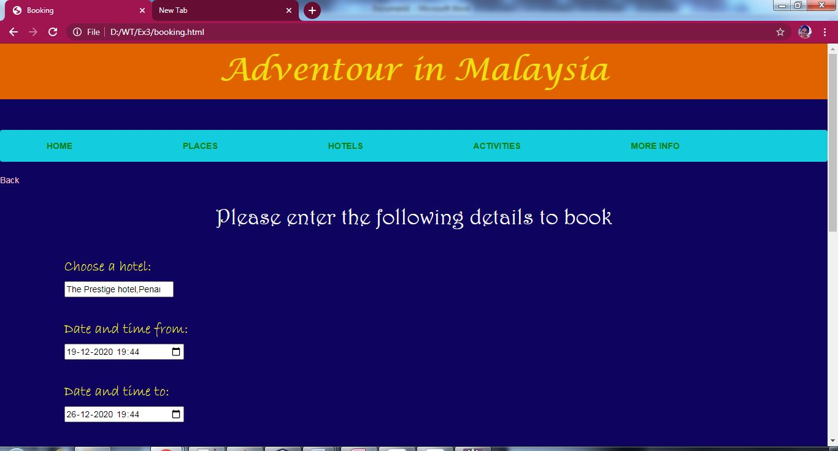

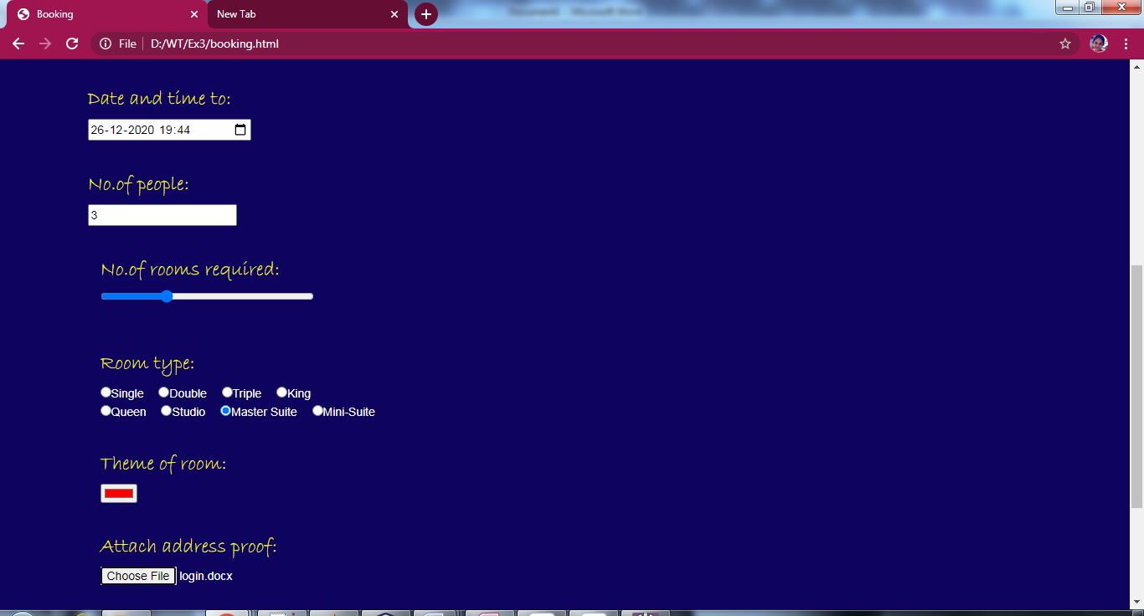

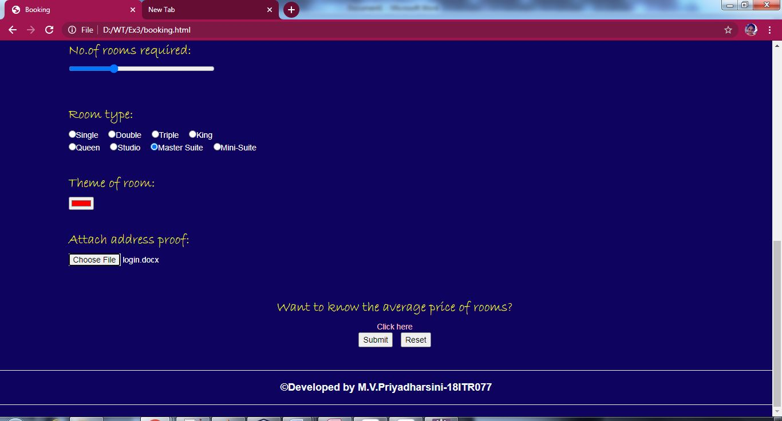

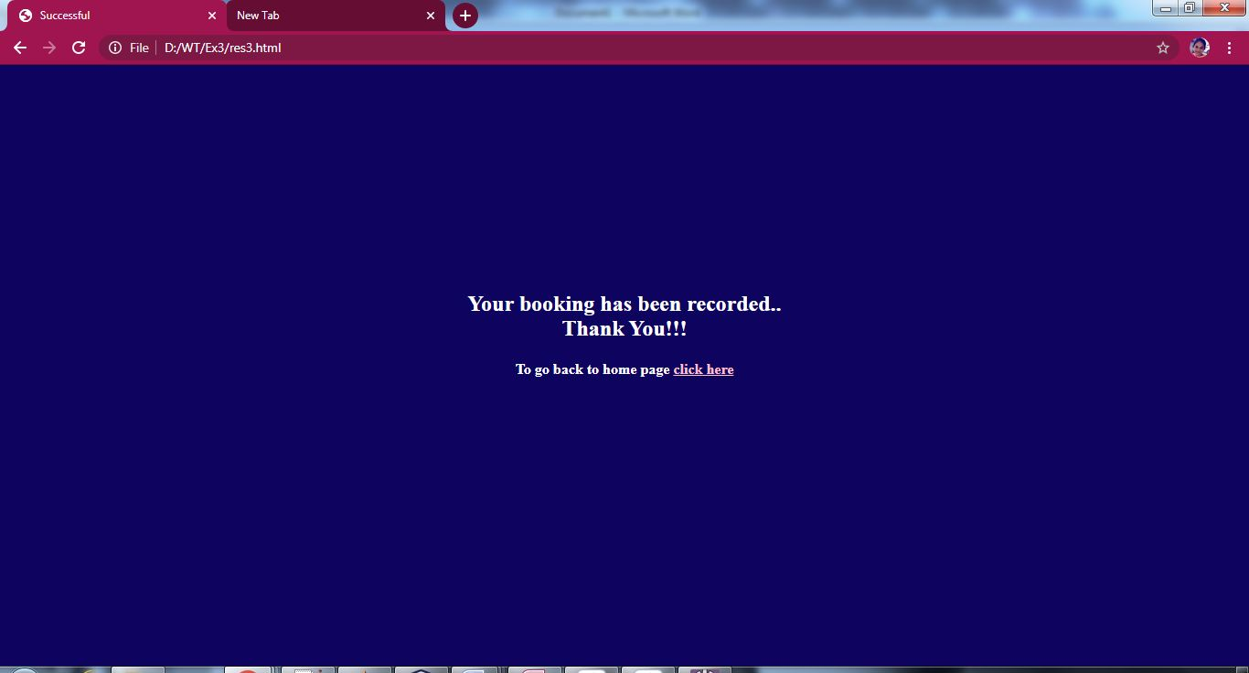

**Avgprice.html**

<html>

<head>

<link rel="stylesheet"type="text/css"href="h1.css"/>

<link rel="stylesheet"type="text/css"href="body.css"/>

<link rel="stylesheet"type="text/css"href="h41.css"/>

<link rel="stylesheet"type="text/css"href="a1.css"/>

<link rel="stylesheet"type="text/css"href="center.css"/>

<link rel="stylesheet"type="text/css"href="footer.css"/>

<style>

table{

color:white;

border:3px solid orange;

padding:5px;

margin:50px;

}

</style>

<title>Average price of Hotels</title>

</head>

<body bgcolor="#0E035F">

<p><a href="booking.html">Back</a></p>

<h1 style="color:yellow"><center>Average price of Rooms in Hotels</center></h1><br>

<center>

<table border="2px" cellpadding="5" cellspacing="0" width="75%" height="50%">

<tr>

<th><h2>Type of room</h2></th>

<th><h2>Average price(per person)</h2></th>

<th><h2>Price for additional adult</h2></th>

</tr>

<tr>

<th><h3>Single</h3></th>

<th><h3>500</h3></th>

<th><h3>100</h3></th>

</tr>

<tr>

<th><h3>Double</h3></th>

<th><h3>1000</h3></th>

<th><h3>120</h3></th>

</tr>

<tr>

<th><h3>Triple</h3></th>

<th><h3>2000</h3></th>

<th><h3>140</h3></th>

</tr>

<tr>

<th><h3>King</h3></th>

<th><h3>2900</h3></th>

<th><h3>150</h3></th>

</tr>

<tr>

<th><h3>Queen</h3></th>

<th><h3>2900</h3></th>

<th><h3>150</h3></th>

</tr>

<tr>

<th><h3>Studio</h3></th>

<th><h3>3300</h3></th>

<th><h3>170</h3></th>

</tr>

<tr>

<th><h3>Master Suite</h3></th>

<th><h3>4400</h3></th>

<th><h3>200</h3></th>

</tr>

<tr>

<th><h3>Mini-Suite</h3></th>

<th><h3>3800</h3></th>

<th><h3>190</h3></th>

</tr>

</table>

</center>

<h3 style="color:orange;font-family:DFKai-SB"><ins>NOTE:</ins></h3>

<ul type="square">

<li><b><em>This is the average price for one night only.</em></b></li>

<li><b><em>The price may from one hotel to another.</em></b></li>

<li><b><em>Additional amount will not be collected for kids below 10 years of age.</em></b></li>

</ul>

<div class="footer">

<hr><h4><center><b>&copy;Developed by M.V.Priyadharsini-18ITR077</b></center></h4><hr>

</div>

</body>

</html>

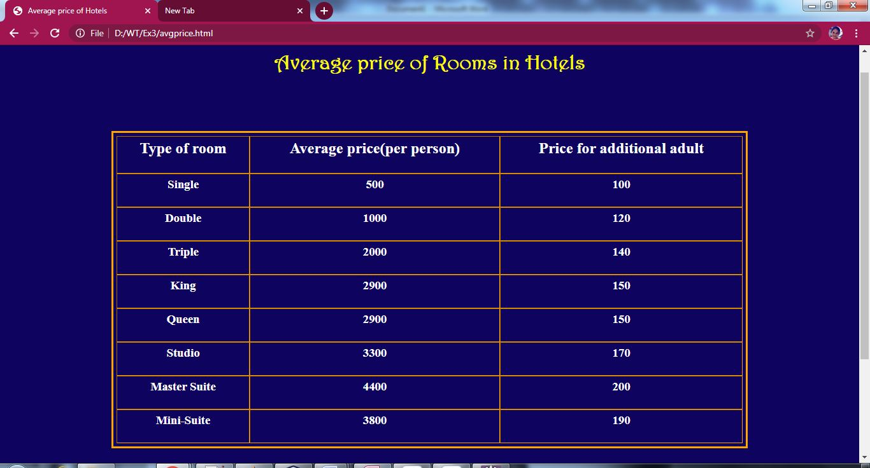

**Activities.html**

<!DOCTYPE html>

<html lang="en">

<head>

<meta charset="utf-8">

<meta name="viewport" content="width=device-width, initial-scale=1">

<link rel="stylesheet" href="https://maxcdn.bootstrapcdn.com/bootstrap/3.4.1/css/bootstrap.min.css">

<script src="https://ajax.googleapis.com/ajax/libs/jquery/3.5.1/jquery.min.js"></script>

<script src="https://maxcdn.bootstrapcdn.com/bootstrap/3.4.1/js/bootstrap.min.js"></script>

<link rel="stylesheet"type="text/css"href="h41.css"/>

<link rel="stylesheet"type="text/css"href="a1.css"/>

<link rel="stylesheet"type="text/css"href="h1.css"/>

<link rel="stylesheet"type="text/css"href="h2.css"/>

<link rel="stylesheet"type="text/css"href="jumbotron.css"/>

<link rel="stylesheet"type="text/css"href="body.css"/>

<style>

a:link {

color: #996515;

}

a:visited {

color: green;

}

a:hover {

color: red;

}

a:active {

color: yellow;

}

.navbar-custom{

background-color:#13CDDF;

}

.navbar-nav > li{

padding-left:30px;

padding-right:120px;

}

</style>

<title>Activities</title>

</head>

<body bgcolor="#0E035F">

<a href="index.html" style="color:pink">Back</a>

<br>

<div class="jumbotron text-center">Adventour in Malaysia</div><br>

<nav class="navbar navbar navbar-custom">

<div class="container-fluid">

<div class="navbar-header">

<button type="button" class="navbar-toggle" data-toggle="collapse" data-target="#myNavbar">

<span class="icon-bar"></span>

<span class="icon-bar"></span>

<span class="icon-bar"></span>

</button>

</div>

<div class="collapse navbar-collapse" id="myNavbar">

<ul class="nav navbar-nav">

<li><a href="index.html"><b>HOME</b></a></li>

<li><a href="places.html"><b>PLACES</b></a></li>

<li><a href="hotels.html"><b>HOTELS</b></a></li>

<li><a href="activities.html"><b>ACTIVITIES</b></a></li>

<li><a href="info.html"><b>MORE INFO</b></a></li>

</ul>

</div>

</div>

</nav>

<h1><center>ACTIVITIES</center></h1>

<div class="container">

<div class="row">

<div class="col-md-4"><iframe width="100%" height="200" src="https://www.youtube.com/embed/_VynWCHfxuM"></iframe><h2><a href="sky.html" style="color:pink">Skydiving</a></h2></div>

<div class="col-md-4"><iframe width="100%" height="200" src="https://www.youtube.com/embed/PxT5CVOsJlo"></iframe><h2><a href="bungee.html" style="color:pink">Bungee Jumping</a></h2></div>

<div class="col-md-4"><iframe width="100%" height="200" src="https://www.youtube.com/embed/mC95lv3iuqM"></iframe><h2><a href="zorb.html" style="color:pink">Zorbing</a></h2></div>

<div>

</div>

<div class="container">

<div class="row">

<div class="col-md-4"><iframe width="100%" height="200" src="https://www.youtube.com/embed/x2YX5b2eS7U"></iframe><h2><a href="kayak.html" style="color:pink">Kayaking</a></h2></div>

<div class="col-md-4"><iframe width="100%" height="200" src="https://www.youtube.com/embed/elDsY6yS9H8"></iframe><h2><a href="surf.html" style="color:pink">Surfing</a></h2></div>

<div class="col-md-4"><iframe width="100%" height="200" src="https://www.youtube.com/embed/r32I8eoHgk8"></iframe><h2><a href="biking.html" style="color:pink">Mountain biking</a></h2></div>

</div>

</div>

<div class="container">

<div class="row">

<div class="col-md-12"><hr>

<h4><center><b>&copy;Developed by M.V.Priyadharsini-18ITR077</b></center></h4><hr>

</div>

</div>

</div>

</body>

</html>

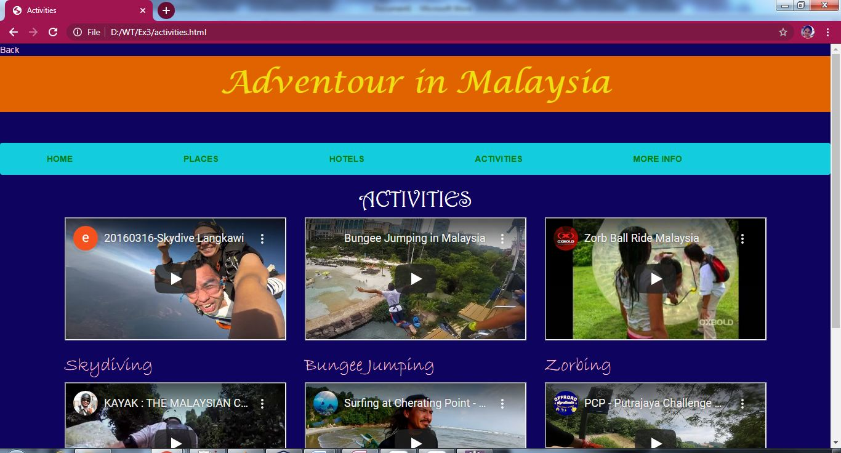

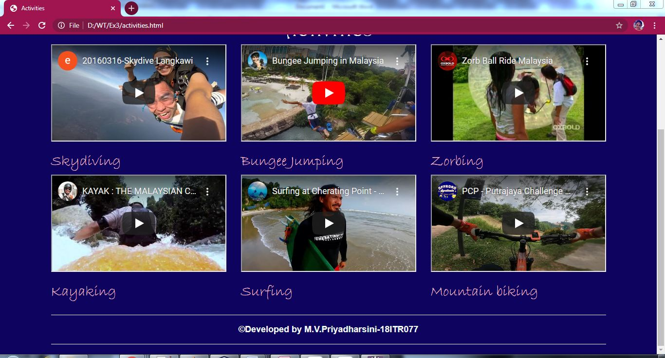

**Sky.html**

<html>

<head>

<link rel="stylesheet"type="text/css"href="body.css"/>

<link rel="stylesheet"type="text/css"href="h1.css"/>

<link rel="stylesheet"type="text/css"href="h31.css"/>

<link rel="stylesheet"type="text/css"href="ul.css"/>

<link rel="stylesheet"type="text/css"href="a1.css"/>

<link rel="stylesheet"type="text/css"href="para.css"/>

<link rel="stylesheet"type="text/css"href="rightdiv.css"/>

<link rel="stylesheet"type="text/css"href="ulist.css"/>

<style>

h1{

color:yellow;

text-align:center;

letter-spacing: 5px;

text-shadow: 2px 2px 2px;

font-size: 250%;

}

h3{

text-decoration:underline;

text-transform: capitalize;

}

ul{

line-height: 2.2;

}

</style>

<title>Skydiving</title>

</head>

<body bgcolor="#0E035F">

<p id="t"></p>

<a href="activities.html" style="color:pink">Back</a>

<h1>Skydiving</h1>

<hr>

<div class="rightdiv">

<a href="#b">Go to Bottom</a>

</div>

<div class="para"><p><h4>Skydiving is parachuting from an airplane for fun. Skydiving can be done individually and with groups of people. Training is required. Unlike most paratroopers, skydivers often wait until they are low, before opening the parachute. The jump can also be made from a helicopter or a balloon that is high enough in the sky. Skydiving can be an exciting sport.</h4></p></div>

<h3>spots for skydiving in malaysia</h3>

<ul type="square">

<li><h4>Hawk skydive,Selangor</h4></li>

<li><h4>AirRider Indoor skydiving,Selangor</h4></li>

<li><h4>Ace Skydive Center,Malacca</h4></li>

<li><h4>Ainurdhiya Airah 75,Johor</h4></li>

</ul>

<h3>rules for skydiving</h3>

<div class="ulist"><ul>

<li><h4>The participants must be a minimum of 18 years of age.</h4></li>

<li><h4>The weight requirement is 225 pounds (and that includes the clothes on your back, shoes on your feet).</h4></li>

</div>

</ul>

<p id="b"></p>

<div class="rightdiv">

<a href="#t">Go to Top</a>

</div>

</body>

</html>

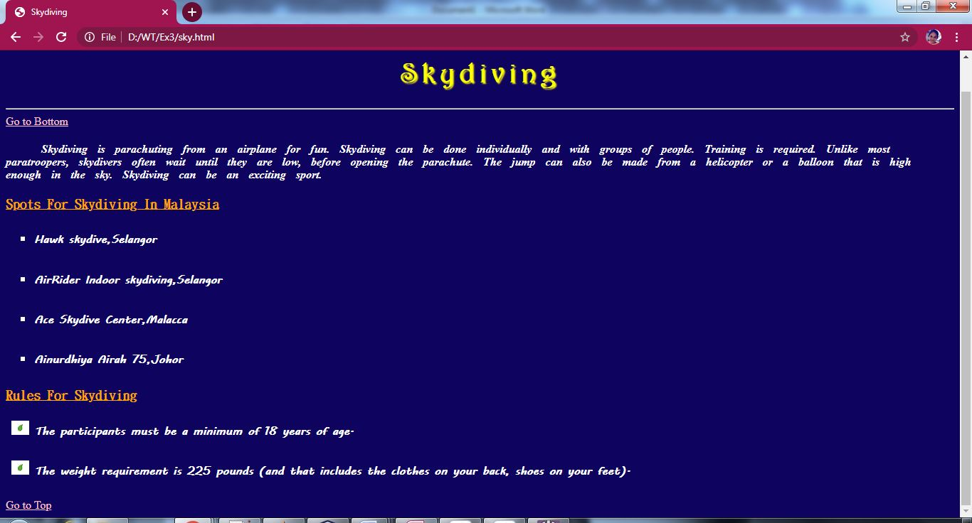

**Bungee.html**

<html>

<head>

<link rel="stylesheet"type="text/css"href="body.css"/>

<link rel="stylesheet"type="text/css"href="h1.css"/>

<link rel="stylesheet"type="text/css"href="h31.css"/>

<link rel="stylesheet"type="text/css"href="a1.css"/>

<link rel="stylesheet"type="text/css"href="ul.css"/>

<link rel="stylesheet"type="text/css"href="para.css"/>

<link rel="stylesheet"type="text/css"href="rightdiv.css"/>

<link rel="stylesheet"type="text/css"href="ulist.css"/>

<style>

h1{

color:yellow;

text-align:center;

letter-spacing: 5px;

text-shadow: 2px 2px 2px;

font-size: 250%;

}

h3{

text-decoration:underline;

text-transform: capitalize;

}

ul{

line-height: 2.2;

}

</style>

<title>Bungee Jumping</title>

</head>

<body bgcolor="#0E035F">

<p id="t"></p>

<a href="activities.html" style="color:pink">Back</a>

<h1>Bunjee Jumping</h1>

<hr>

<div class="rightdiv">

<a href="#b">Go to Bottom</a>

</div>

<div class="para"><p><h4>Bungee jumping is an adventurous sport in which people jump from higher ground such as a bridge with an elastic rope tied to their ankles to stop them from hitting the ground. The rope is designed to stretch, not break. When the rope has stretched all the way, the jumper bounces back up. When people jump they wear safety equipment like helmets and a harness.</h4></p></div>

<h3>spots for bunjee jumping in malaysia</h3>

<ul type="square">

<li><h4>Sunway Extreme Park,Selangor</h4></li>

<li><h4>Bridge Rope Swing,Selangor</h4></li>

<li><h4>Sunway Lagoon,Selangor</h4></li>

<li><h4>Menara,Kuala Lumpur</h4></li>

</ul>

<h3>rules for bungee jumping</h3>

<div class="ulist"><ul>

<li><h4>The participants must be a minimum of 12 to 14 years of age</h4></li>

<li><h4> The participants must have a minimum weight of around 35kg, and a maximum of around 110kg.</h4></li>

<li><h4>If the participant suffers from a heart condition, epilepsy, high blood pressure, diabetes, neurological disorder, or is pregnant, it is advised that you don’t attempt the jump</h4></li>

</div>

</ul>

<p id="b"></p>

<div class="rightdiv">

<a href="#t">Go to Top</a>

</div>

</body>

</html>

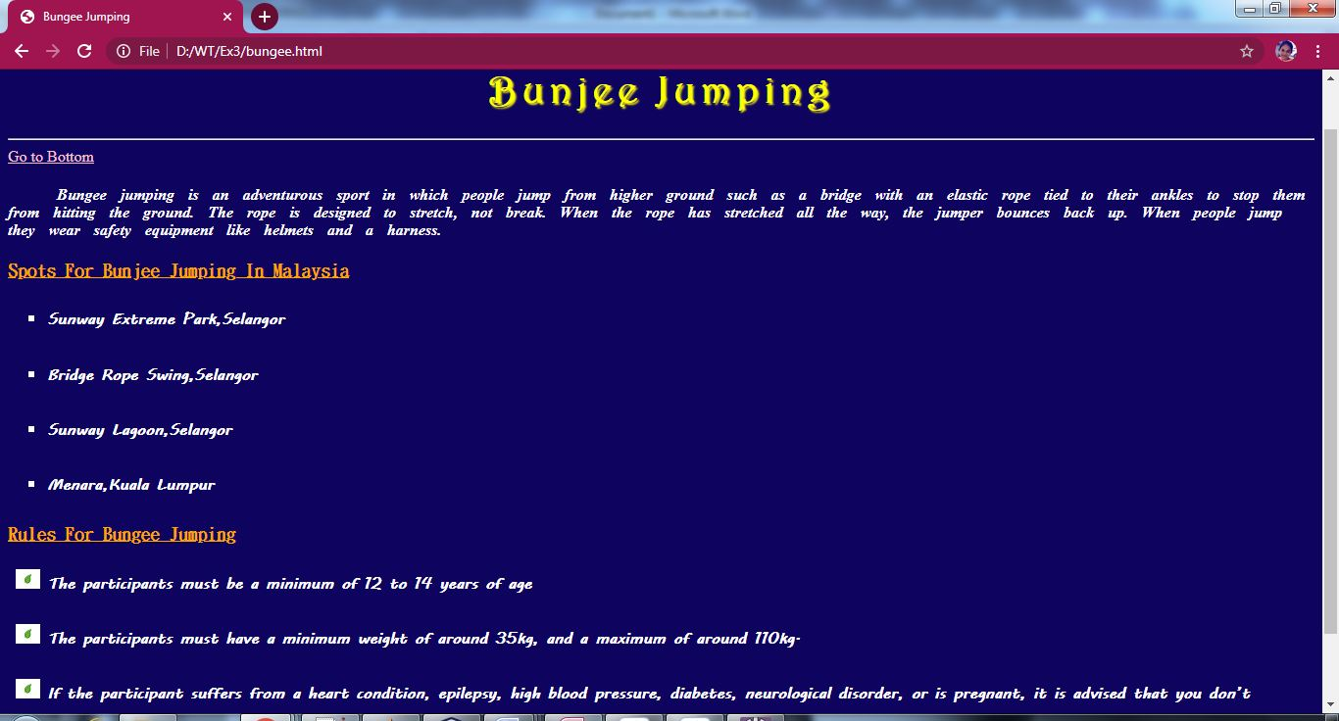

**Zorb.html**

<html>

<head>

<link rel="stylesheet"type="text/css"href="body.css"/>

<link rel="stylesheet"type="text/css"href="h1.css"/>

<link rel="stylesheet"type="text/css"href="h31.css"/>

<link rel="stylesheet"type="text/css"href="a1.css"/>

<link rel="stylesheet"type="text/css"href="ul.css"/>

<link rel="stylesheet"type="text/css"href="para.css"/>

<link rel="stylesheet"type="text/css"href="rightdiv.css"/>

<link rel="stylesheet"type="text/css"href="ulist.css"/>

<style>

h1{

color:yellow;

text-align:center;

letter-spacing: 5px;

text-shadow: 2px 2px 2px;

font-size: 250%;

}

h3{

text-decoration:underline;

text-transform: capitalize;

}

ul{

line-height: 2.2;

}

</style>

<title>Zorbing</title>

</head>

<body bgcolor="#0E035F">

<p id="t"></p>

<a href="activities.html" style="color:pink">Back</a>

<h1>Zorbing</h1>

<hr>

<div class="rightdiv">

<a href="#b">Go to Bottom</a>

</div>

<div class="para"><p><h4>Zorbing (also known as globe-riding, sphereing, orbing) is the recreation or sport of rolling downhill inside an orb, typically made of transparent plastic.[1] Zorbing is generally performed on a gentle slope but can also be done on a level surface, permitting more rider control. In the absence of hills, some operators have constructed inflatable, wooden, or metal ramps.</h4></p></div>

<h3>spots for bunjee jumping in malaysia</h3>

<ul type="square">

<li><h4>Arena 51,Selangor</h4></li>

<li><h4>Oxbold Sports Center,Pahang</h4></li>

<li><h4>SphereCraze,Serdang</h4></li>

</ul>

<h3>rules for bungee jumping</h3>

<div class="ulist"><ul>

<li><h4>Jewelry should be removed prior to the ride.</h4></li>

<li><h4> The combined wight of all the participants must be under 180kg.</h4></li>

<li><h4>Check that once inside, you are securely strapped in.</h4></li>

</div>

</ul>

<p id="b"></p>

<div class="rightdiv">

<a href="#t">Go to Top</a>

</div>

</body>

</html>

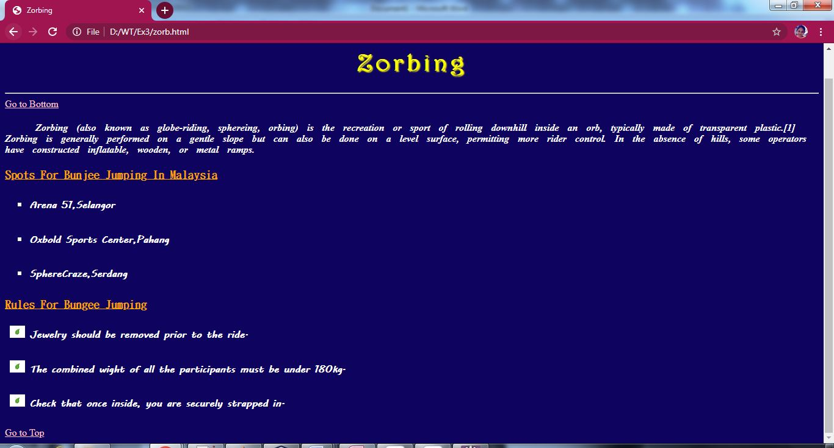

**Kayak.html**

<html>

<head>

<link rel="stylesheet"type="text/css"href="body.css"/>

<link rel="stylesheet"type="text/css"href="h1.css"/>

<link rel="stylesheet"type="text/css"href="h31.css"/>

<link rel="stylesheet"type="text/css"href="ul.css"/>

<link rel="stylesheet"type="text/css"href="a1.css"/>

<link rel="stylesheet"type="text/css"href="para.css"/>

<link rel="stylesheet"type="text/css"href="rightdiv.css"/>

<link rel="stylesheet"type="text/css"href="ulist.css"/>

<style>

h1{

color:yellow;

text-align:center;

letter-spacing: 5px;

text-shadow: 2px 2px 2px;

font-size: 250%;

}

h3{

text-decoration:underline;

text-transform: capitalize;

}

ul{

line-height: 2.2;

}

</style>

<title>Kayaking</title>

</head>

<body bgcolor="#0E035F">

<p id="t"></p>

<a href="activities.html" style="color:pink">Back</a>

<h1>Kayaking</h1>

<hr>

<div class="rightdiv">

<a href="#b">Go to Bottom</a>

</div>

<div class="para"><p><h4>Kayaking is the use of a kayak for moving across water. It is distinguished from canoeing by the sitting position of the paddler and the number of blades on the paddle. A kayak is a low-to-the-water, canoe-like boat in which the paddler sits facing forward, legs in front, using a double-bladed paddle to pull front-to-back on one side and then the other in rotation</h4></p></div>

<h3>spots for kayaking in malaysia</h3>

<ul type="square">

<li><h4>White Water Rafting Malaysia,Perak</h4></li>

<li><h4>The Rucksack Rainforest Kayaking,Sarawak</h4></li>

<li><h4>Xtreme Langkawi Mangrove Kayaking,Kedah</h4></li>

<li><h4>Alanona Guided Kayak Tour,Kedah</h4></li>

</ul>

<h3>rules for kayaking</h3>

<div class="ulist"><ul>

<li><h4>Invest in appropriate clothing for your climate.</h4></li>

<li><h4>Wear your Personal Floatation Device.</h4></li>

<li><h4>Never mix alcohol or drugs with boating.</h4></li>

</div>

</ul>

<p id="b"></p>

<div class="rightdiv">

<a href="#t">Go to Top</a>

</div>

</body>

</html>

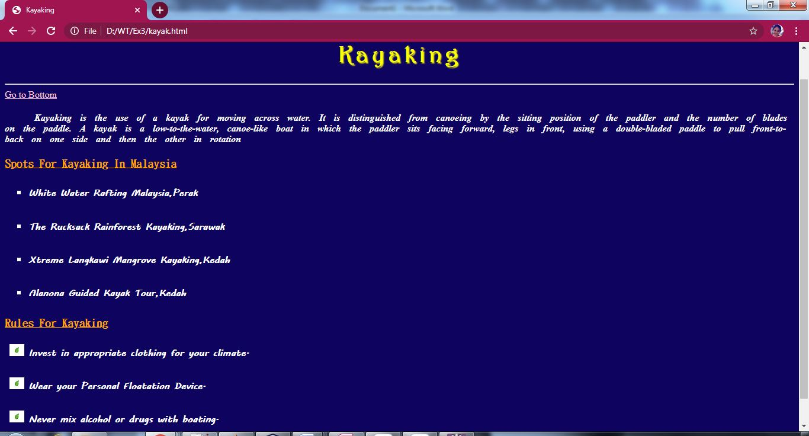

**Surf.html**

<html>

<head>

<link rel="stylesheet"type="text/css"href="body.css"/>

<link rel="stylesheet"type="text/css"href="h1.css"/>

<link rel="stylesheet"type="text/css"href="h31.css"/>

<link rel="stylesheet"type="text/css"href="ul.css"/>

<link rel="stylesheet"type="text/css"href="a1.css"/>

<link rel="stylesheet"type="text/css"href="para.css"/>

<link rel="stylesheet"type="text/css"href="rightdiv.css"/>

<link rel="stylesheet"type="text/css"href="ulist.css"/>

<style>

h1{

color:yellow;

text-align:center;

letter-spacing: 5px;

text-shadow: 2px 2px 2px;

font-size: 250%;

}

h3{

text-decoration:underline;

text-transform: capitalize;

}

ul{

line-height: 2.2;

}

</style>

<title>Surfing</title>

</head>

<body bgcolor="#0E035F">

<p id="t"></p>

<a href="activities.html" style="color:pink">Back</a>

<h1>Surfing</h1>

<hr>

<div class="rightdiv">

<a href="#b">Go to Bottom</a>

</div>

<div class="para"><p><h4>Surfing is a surface water pastime in which the wave rider, referred to as a surfer, rides on the forward part, or face, of a moving wave, which usually carries the surfer towards the shore. Waves suitable for surfing are primarily found in the ocean, but can also be found in lakes or rivers in the form of a standing wave or tidal bore.</h4></p></div>

<h3>spots for surfing in malaysia</h3>

<ul type="square">

<li><h4>Cherating point,Pahang</h4></li>

<li><h4>Satusuku,Pahang</h4></li>

<li><h4>Kam's Surf Shack,Pahang</h4></li>

<li><h4>Wildboar bay,Johor</h4></li>

</ul>

<h3>rules for surfing</h3>

<div class="ulist"><ul>

<li><h4>When you are paddling to catch a wave, you are not allowed to catch it when there is someone paddling next to you on your left.</h4></li>

<li><h4>Do not drop in.</h4></li>

<li><h4>Don't ditch your board</h4></li>

</div>

</ul>

<p id="b"></p>

<div class="rightdiv">

<a href="#t">Go to Top</a>

</div>

</body>

</html>

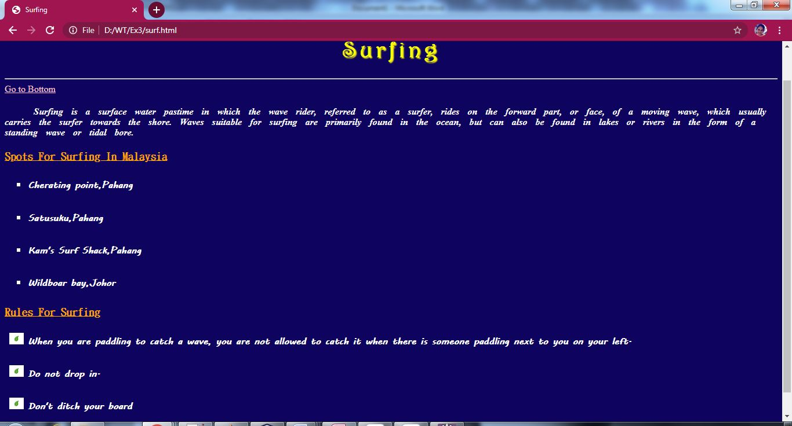

**Biking.html**

<html>

<head>

<link rel="stylesheet"type="text/css"href="body.css"/>

<link rel="stylesheet"type="text/css"href="h1.css"/>

<link rel="stylesheet"type="text/css"href="h31.css"/>

<link rel="stylesheet"type="text/css"href="ul.css"/>

<link rel="stylesheet"type="text/css"href="a1.css"/>

<link rel="stylesheet"type="text/css"href="para.css"/>

<link rel="stylesheet"type="text/css"href="rightdiv.css"/>

<link rel="stylesheet"type="text/css"href="ulist.css"/>

<style>

h1{

color:yellow;

text-align:center;

letter-spacing: 5px;

text-shadow: 2px 2px 2px;

font-size: 250%;

}

h3{

text-decoration:underline;

text-transform: capitalize;

}

ul{

line-height: 2.2;

}

</style>

<title>Mountain biking</title>

</head>

<body bgcolor="#0E035F">

<p id="t"></p>

<a href="activities.html" style="color:pink">Back</a>

<h1>Mountain biking</h1>

<hr>

<div class="rightdiv">

<a href="#b">Go to Bottom</a>

</div>

<div class="para"><p><h4>Mountain biking is a sport of riding bicycles off-road, often over rough terrain, using specially designed mountain bikes. Mountain bikes share similarities with other bikes but incorporate features designed to enhance durability and performance in rough terrain.Mountain biking can generally be broken down into multiple categories: cross country, trail riding, all mountain (also referred to as "Enduro"), downhill, freeride and dirt jumping.</h4></p></div>

<h3>spots for surfing in malaysia</h3>

<ul type="square">

<li><h4>Bukit Kiara Downhill Mountain Bike Trail,Kuala Lumpur</h4></li>

<li><h4>Chengkuan Mountain Bike Trail,Kedah</h4></li>

<li><h4>Seri Alam Bike Park,Johor</h4></li>

<li><h4>Bicycle World Sdn Bhd,Kuala Lumpur</h4></li>

</ul>

<h3>rules for surfing</h3>

<div class="ulist"><ul>

<li><h4>Always wear a helmet and fasten it.</h4></li>

<li><h4>Shift into lower gears when biking up hills to reserve energy.</h4></li>

<li><h4>Wear bright clothing so drivers and other trail users can see you.</h4></li>

<li><h4>Do not ride wet and soft trails.</h4></li>

</div>

</ul>

<p id="b"></p>

<div class="rightdiv">

<a href="#t">Go to Top</a>

</div>

</body>

</html>

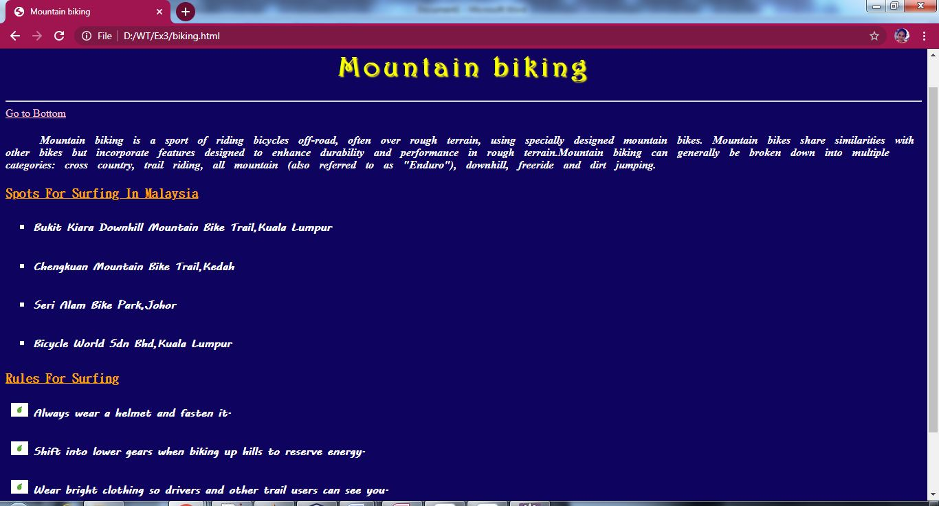

**Info.html**

<!DOCTYPE html>

<html lang="en">

<head>

<meta charset="utf-8">

<meta name="viewport" content="width=device-width, initial-scale=1">

<link rel="stylesheet" href="https://maxcdn.bootstrapcdn.com/bootstrap/3.4.1/css/bootstrap.min.css">

<script src="https://ajax.googleapis.com/ajax/libs/jquery/3.5.1/jquery.min.js"></script>

<script src="https://maxcdn.bootstrapcdn.com/bootstrap/3.4.1/js/bootstrap.min.js"></script>

<link rel="stylesheet"type="text/css"href="body.css"/>

<link rel="stylesheet"type="text/css"href="a1.css"/>

<link rel="stylesheet"type="text/css"href="h1.css"/>

<link rel="stylesheet"type="text/css"href="h2.css"/>

<link rel="stylesheet"type="text/css"href="h3.css"/>

<link rel="stylesheet"type="text/css"href="h41.css"/>

<link rel="stylesheet"type="text/css"href="jumbotron.css"/>

<style>

h3{

font-family:Harrington;

}

a:link {

color: #996515;

}

a:visited {

color: green;

}

a:hover {

color: red;

}

a:active {

color: yellow;

}

.navbar-custom{

background-color:#13CDDF;

}

.navbar-nav > li{

padding-left:30px;

padding-right:120px;

}

</style>

<title>More Information</title>

</head>

<body bgcolor="#0E035F">

<p id="t"></p>

<a href="index.html" style="color:pink">Back</a>

<br>

<div class="jumbotron text-center">Adventour in Malaysia</div><br>

<nav class="navbar navbar navbar-custom">

<div class="container-fluid">

<div class="navbar-header">

<button type="button" class="navbar-toggle" data-toggle="collapse" data-target="#myNavbar">

<span class="icon-bar"></span>

<span class="icon-bar"></span>

<span class="icon-bar"></span>

</button>

</div>

<div class="collapse navbar-collapse" id="myNavbar">

<ul class="nav navbar-nav">

<li><a href="index.html"><b>HOME</b></a></li>

<li><a href="places.html"><b>PLACES</b></a></li>

<li><a href="hotels.html"><b>HOTELS</b></a></li>

<li><a href="activities.html"><b>ACTIVITIES</b></a></li>

<li><a href="info.html"><b>MORE INFO</b></a></li>

</ul>

</div>

</div>

</nav>

<h1><center>MORE INFORMATION</center></h1>

<hr>

<div class="text-right">

<a href="#b" style="color:pink">Go to Bottom</a>

</div>

<br>

<h3><ins>Relevant tips on Language and Local dilect</ins></h3>

<p><h4><b><em>The official language of Kuala Lumpur is Malaysian, which is also referred to as Malaysian Malay or simply just Malay. This is spoken by the majority of the people in Kuala Lumpur, closely followed by the English language. Other than these, Chinese dialects such as Mandarin and Hokkien are also quite common, and so is the Tamil language, which is primarily spoken by the Indians who now reside in Kuala Lumpur. </p></h4></b></em>

<h3><ins>National Anthem</ins></h3>

<audio controls><source src="Malaysia.mp3" type="audio/mp3"></audio>

<h3><ins>Public Transport Information</ins></h3>

<p><h4><b><em>Malaysia’s transport system is developed and covers up to 63,445 kms, including 1,630 kms of expressways. The main highway connects Thai border and Singapore which is a stretch of 800 kms. The modes of transport are trains, buses, cars and airplanes.</p></h4></b></em>

<ol type="I">

<li style="color:orange">Road Tansport</li>

<p><h4><b><em>Traveling by bus is the cheapest way to travel in the city. There are air-conditioned buses connecting various places within and outside the city. Non air-conditioned buses are also available which usually run in the smaller towns.

Inter state connecting buses have fixed rates but buses running within the city charge according to the distance traveled.</p></h4></b></em>

<li style="color:orange">Rail System</li>

<p><h4><b><em>Malayan railways or Keretapi Tanah Melayu Berhad (KTM) connects all the major cities/towns in the Peninsular Malaysia. One can travel by rail from Peninsular Malaysia via Thailand and Singapore. First, second and economy air-conditioned coaches are available in the trains.</p></h4></b></em>

<li style="color:orange">Air Transport</li>

<p><h4><b><em>Kuala Lumpur International Airport (KLIA) is located at Sepang which is 50 kms away from the capital, Kuala Lumpur. Over 40 airlines arrive and depart from KLIA including Malaysia’s own airlines, Malaysian Airlines.

Passengers can take connecting flights from KLIA to the major cities in Malaysia including Sabah and Sarawak.</p></h4></b></em>

</ol>

<h3><ins>Packing Tips</ins></h3>

<ul>

<li><p><h4><b><em>The heat and humidity in Kuala Lumpur can be really intense, so it’s important you pack clothing that will help you stay cool.</li></p></h4></b></em>

<li><p><h4><b><em>You’ll most likely be doing a LOT of walking so it’s important you wear sensible shoes that are very comfortable.</li></p></h4></b></em>

<li><p><h4><b><em>Be sure to pack a raincoat, umbrella or other waterproof gear as it does rain quite often</li></p></h4></b></em>

<li><p><h4><b><em>In Kuala Lumpur, power sockets are G Type, which is the boxy one with three thick, rectangular prongs. Be sure to pack an adaptor so you can charge all your electronics.</li></p></h4></b></em>

<li><p><h4><b><em>Finally, be sure to pack light! If you love shopping, KL is a bit of a shopper’s wonderland and you’re going to need room in your suitcase for all those new purchases! So, keep it light.</li></p></h4></b></em>

</ul>

<h3><ins>Maps and Guides</ins></h3>

<center><img src="map.gif"/>

<p><h4><b><address>For more info<br>Contact:9842753953<br>Mail:<a href="mailto:priyadharsinimv.18it@kongu.edu" style="color:orange">priyadharsinimv.18it@kongu.edu</a></address></b></h4></p>

</center>

<p id="b"></p>

<div class="text-right">

<a href="#t" style="color:pink">Go to Top</a><br><hr>

</div>

<div class="col-sm-12">

<h4><center><b>&copy;Developed by M.V.Priyadharsini-18ITR077</b></center></h4><hr>

</div>

</body>

</html>

